A Machine Learning Approach to Predicting Future Onset of Type II Diabetes

Preston John Badger
Concordia International School Hanoi, Ha Noi, Vietnam

Author Note
Correspondence concerning this article should be addressed to:
Preston John Badger: preston.badger@concordiahanoi.org

Abstract
Type 2 diabetes represents a significant global health challenge. This research seeks to refine the prediction of Type 2 diabetes onset by leveraging data from the National Health and Nutrition Examination Survey (NHANES), spanning from 1988 to 2018. The objective is to address the existing deficiencies in model performance, aiming to provide healthcare professionals with a more dependable tool for diabetes prediction. Although previous studies have contributed valuable insights and models, their practical applicability in clinical settings remains questionable due to inconsistent evaluation outcomes. This study evaluates the efficacy of various machine learning models, including Logistic Regression, Support Vector Machines (SVM), Random Forest, and XGBoost, as well as an ensemble approach that synthesizes their strengths. A comprehensive feature selection process incorporates examination, dietary, questionnaire, and demographic data, ensuring a robust model configuration for predicting the onset of Type 2 diabetes in the U.S. population.
The chosen models, evaluated on ROC-AUC, Precision, Recall, and F1 Score, showed notable performance across two segments of data: case I, which targeted Diabetic and Non-Diabetic patients, and case II, which emphasized Undiagnosed Diabetic and Pre-Diabetic patients. When evaluated using test data for these cases, the models demonstrated high efficacy, particularly the Random Forest and XGBoost models, which exhibited nearly perfect ROC-AUC scores in Case I.
This paper, when evaluated by its ROC-AUC metric, achieved 0.9772 for case I and 0.9806 for case II. This result, when compared to other papers in the field, differed significantly: for instance, (Dinh et al., 2019), the inspiration for the idea of splitting the data into two distinct cases, achieved 0.944 for Case I and 0.783 for Case II respectively.
Another noteworthy paper, which did not split the data into two cases: (Semerdjian and Frank, 2017), achieved 0.834. Both papers’ results, while of high merit, are noted as being lower than this paper’s ensemble model’s performance, a testament to model improvement in this field.
These results underscore the potential of machine learning in accurately predicting Type 2 Diabetes onset. The developed models, particularly the ensemble model, show high accuracy and offer a comprehensive view of risk factors. The study highlights the ongoing need for research in this area to refine predictive models and improve their applicability in real-world healthcare settings.
Keywords: Type 2 Diabetes, Machine Learning, Health Analytics, Feature Learning, Ensemble Modeling

A Machine Learning Approach to Predicting Future Onset of Type II Diabetes
Recent advancements in machine learning have catalyzed a transformative wave in the healthcare domain (Dinh et al., 2019). These innovations hold particular promise for chronic diseases such as Type 2 Diabetes, a condition that has been extensively characterized in the literature and has seen a concerning uptrend in the United States over the last few decades (Chatterjee et al., 2017). The current landscape of healthcare necessitates the need for novel, data-driven strategies to better predict, manage, and ultimately prevent its onset, given the increasing prevalence rates of this metabolic disorder (Semerdjian and Frank, 2017).
Previous research endeavors have primarily focused on characterizing diseases and elucidating their primary risk factors, often debating the balance between explanatory and predictive modeling (Shmueli, 2010). However, the exponential growth in health-related data repositories like NHANES presents a compelling opportunity to harness the potential of predictive modeling (Dinh et al., 2019). The utility of machine learning in healthcare applications, especially for predicting diseases, is well recognized and has been demonstrated in studies such as those by Yu et al. (2010), which explored support vector machine modeling for predicting common diseases (et al., 2010).
Yet, the specific ability of machine learning in leveraging datasets like NHANES for predicting Type 2 Diabetes onset remains a relatively under-explored territory, as noted in Teimouri and Alavinia’s paper (Teimouri and Alavinia, 2015). This research seeks to bridge this gap by drawing inspiration from ensemble classifier strategies that have previously been shown to be effective in predicting the onset of Type II Diabetes (Semerdjian and Frank, 2017). This study differentiates itself by implementing a comprehensive model evaluation framework that critically assesses both the efficacy and applicability of these machine-learning strategies in real-world clinical settings, an aspect that is often glossed over in existing literature. Furthermore, it integrates advanced feature selection techniques to enhance the predictive power and clinical relevance of the models, thereby contributing to a more nuanced understanding of diabetes risk factors, a point highlighted in the work of Chen and Lin (Chen and Lin, 2006). In doing so, it not only evaluates the accuracy and performance metrics of the predictive models but also underscores the pivotal trends and risk factors integral to disease onset, aligning with feature selection strategies often employed in machine learning.
This study aims to determine the efficacy of machine learning in predicting the onset of Type 2 Diabetes in the United States using the NHANES dataset spanning 1988 to 2018, mapping out a comprehensive trajectory for the paper’s discourse.

Methods
Data Source and Participants
The core data for our study comes from the National Health and Nutrition Examination Survey, commonly known as NHANES. This survey, conducted by CDC/NCHS, has been active since the 1960s. There were seven distinct national surveys from 1960 to 1994, but the program transitioned to a continuous model from 1999, releasing data every two years (“National Health and Nutrition Examination Survey (NHANES),” n.d.
NHANES, a pivotal initiative of the U.S. CDC, offers a deep dive into the health and nutritional patterns of the U.S. populace. Its standout feature is the combination of detailed interviews with thorough physical assessments. In these assessments, conducted in Mobile Examination Centers (MEC), participants undergo a range of tests. These span from fundamental metrics like height and weight to specialized examinations for vision, hearing, and respiratory metrics (“National Health and Nutrition Examination Survey (NHANES),” n.d.). Additionally, laboratory tests delve deeper into areas like hematology, environmental exposures, and organ function (“National Health and Nutrition Examination Survey (NHANES),” n.d.).
The interview aspect of NHANES gathers a wealth of information, including demographics, health habits, mental well-being, medication usage, and more. The data also encompasses prevalent health conditions, dietary patterns, and physical activity habits (“National Health and Nutrition Examination Survey (NHANES),” n.d.). The detailed evaluations in the MECs provide insight into nutritional health, vaccination records, and environmental influences, among others (“National Health and Nutrition Examination Survey (NHANES),” n.d., providing insight into the prevalence of undiagnosed conditions.
Originally, from 1988 to 1994, the NHANES survey catered to the U.S. civilian population aged 2 months and above. However, post-1999, the study embraced participants across all age groups, painting a more comprehensive picture of the nation’s health (“National Health and Nutrition Examination Survey (NHANES),” n.d.). NHANES employs a rigorous oversampling method to ensure statistical reliability. Notably, since 2011, it has specifically oversampled groups such as Hispanics, non-Hispanic blacks, and non-Hispanic Asians (“National Health and Nutrition Examination Survey (NHANES),”
n.d. 2015-16 marked a pivotal change in the sampling design, adjusting the threshold for low-income oversampling (“National Health and Nutrition Examination Survey (NHANES),” n.d.).
To provide a snapshot, in the 2017-2018 NHANES cycle, 16,211 individuals were eligible, 9,254 of which participated in interviews, and 8,704 underwent the health examination (“National Health and Nutrition Examination Survey (NHANES),” n.d.). Such numbers highlight NHANES’s extensive coverage and strong participation rates.
Leveraging the rich and varied data from NHANES, this research aims to shed light on prevailing health tendencies and associated risk factors.
A point of discussion on the NHANES dataset is its use of self-reported data, in which participants provide information about themselves without interference from the experimenter.
This self-reported data is factually accurate and valid, as the collection of NHANES data and the survey’s design and structure helped to remove issues of self-reported data.
For instance, according to the National Health and Nutrition Examination Survey’s Official Document on Plan and Operations for the 1999-2010 surveys (Centers for Disease Control and Prevention, n.d.), NHANES data were not obtained using a simple random sample.
Rather, a complex, multistage probability sampling design was used to select a sample representative of the civilian non-institutionalized household population of the United States. Sample selection for NHANES followed these stages, in order:

- Selection of primary sampling units (PSUs), which are counties or small groups of contiguous counties.

- Selection of segments within PSUs that constitute a block or group of blocks containing a cluster of households. This indicates that PSUs are used for cluster sampling, where entire groups or clusters are randomly selected from the population, and then a subset of elements within each selected cluster in samples.

- Selection of specific households within segments, and Selection of individuals within a household. This ensured that the PSUs were stratified based on certain characteristics to ensure representation across different strata within the population, which helped improve the precision and representativeness of the sample.

In addition, if abnormal findings were discovered during a MEC examination — the NHANES examinations that took place in the mobile examination center (MEC) due to the controlled environment of the MEC allowing for physical measurements to be done under identical conditions at each survey location, the physician discussed these findings with the sample participant. The physician also made referrals if necessary. For the NHANES findings, both early and regular reports, if abnormal findings were received, an early reporting letter describing the finding was sent to the sample participant (or parent, if a minor), urging the participant to see a medical provider for evaluation. The participant also had the option to talk with the DHANES medical officer.
Relevant Terminology Definitions
Machine Learning (ML): A computational technique where algorithms are designed to improve and adapt their performance by exposure to data without explicit programming.
Ensemble Modeling: An approach in machine learning where multiple models are trained and combined to solve a particular problem. This often results in improved performance compared to using a single model.
AUC (Area Under Curve): A performance metric that evaluates the ability of a binary classification model to differentiate between the positive and negative classes.
Precision: The fraction of relevant instances among the retrieved instances.

Recall: The fraction of the total number of relevant instances that were retrieved.

F1 Score: A measure that combines both precision and recall to provide a single metric for model performance.
NHANES: The National Health and Nutrition Examination Survey, a program that assesses the health and nutritional status of adults and children in the U.S.

Data Collection
Four primary datasets encompassing examination, dietary, questionnaire, and demographics were compiled from the Center for Disease Control (CDC), specifically the National Health and Nutrition Examination Survey from 1988-2018, a free and publicly available dataset on the CDC website. Merged using the SEQN column as a common identifier, duplicates were systematically eradicated.

Feature Selection Techniques
In the efforts to predict diabetes using machine learning models with NHANES data, prior research has identified a set of important variables. Fourteen key variables were
identified by (et al., 2010) for training their machine learning models, including family history, age, gender, race and ethnicity, weight, height, waist circumference, BMI, hypertension, physical activity, smoking, alcohol use, education, and household income. They utilized strategies that combined SVMs with feature selection techniques described by (Chen and Lin, 2006). Furthermore, (Semerdjian and Frank, 2017) employed the same features as (et al., 2010) but included two additional variables: cholesterol and leg length. Their selection was influenced by the analysis conducted by (Heredia-Langner et al., 2013), who employed genetic algorithms and tree-based classification to identify important features for diabetes prediction.
In this study, an ensemble of 24 features was curated, primarily inspired by their diagnostic relevance to diabetes and insights from the aforementioned research, specifically the paper by (Dinh et al., 2019). The selection of these features underwent further refinement, considering their clinical implications; correlation with the target variables: DIQ170, which is the patients’ response to the question: ”Has a doctor ever told you that you are at high risk for diabetes?”; and LBXGH, which represents the Plasma fasting glucose levels, measured in milligrams per deciliter; and non-numeric columns were transformed into numeric formats using well-defined functions. To ensure data integrity, missing values were carefully managed, with median imputation used in replace of the missing values.

Class Definition and Label Assignment:

Inspired by the methodology in (Dinh et al., 2019), for diabetes classification, labels were assigned under two categories: case I and case II, which allowed the model to effectively separate different conditions and cases of patients for the model to analyze. In one category was case I, which consisted of classifying patients as diabetic or non-diabetic; in another category was case II, which consisted of classifying patients as undiagnosed diabetic or pre-diabetic.

For each case, as presented in Table 1, there were four labels assigned to patients each of which was given a different value of either label = 1 or label = 0. In case I, diabetic and undiagnosed diabetic were assigned label = 1, while pre-diabetic and not diabetic were assigned label = 0. In case II, undiagnosed and pre-diabetic were assigned label = 1, while diabetic and not diabetic patients were assigned label = 0.

- Diabetic patients were classified as having replied "Yes" (output = 1 ) to the question: "Has a doctor ever told you that you are at high risk for diabetes?" or having a Plasma fasting glucose (mg/dL) score of greater than 126 mg/dL.
- Diabetic patients were classified as having replied "Yes" (output = 1 ) to the question: "Has a doctor ever told you that you are at high risk for diabetes?" or having a Plasma fasting glucose (mg/dL) score of greater than 126 mg/dL.
- Undiagnosed patients were classified as having replied "No" (output = 0 ) to the question: "Has a doctor ever told you that you are at high risk for diabetes?" or having a Plasma fasting glucose (mg/dL) score of greater than 126 mg/dL.
- Prediabetic patients were classified as having replied "Yes" (output = 1 ) to the question: "Has a doctor ever told you that you are at high risk for diabetes?" or having a Plasma fasting glucose (mg/dL) score of between 100 and 125 mg/dL.
- Not diabetic patients were classified as having a Plasma fasting glucose (mg/dL) score of lower than 100 mg/dL.

Table 1

Diabetes Classification Criteria

Criteria | Classification
Replied "Yes" (output = 1 ) to the question:  "Has a doctor ever told you that you are at high risk for diabetes?" or had a Plasma fasting glucose (mg/dL) score of greater than 126 mg/dL. | Diabetic
Replied "No" (output = 0 ) to the question:  "Has a doctor ever told you that you are at high risk for diabetes?" or had a Plasma fasting glucose (mg/dL) score of less than 126 mg/dL. | Undiagnosed diabetic
Replied "Yes" (output = 1 ) to the question:  "Has a doctor ever told you that you are at high risk for diabetes?" or had a Plasma fasting glucose (mg/dL) score of between 100 and 125 mg/dL. | Pre-diabetic
Had a Plasma fasting glucose (mg/dL) score of lower than 100 mg/dL. | Not diabetic

Data Preparation:
Adhering to best practices, data normalization was achieved using MinMax normalization, ensuring all features scale between 0 and 1, thereby promoting model convergence. The challenge of inherent class imbalances was tackled head-on using the SMOTE (Synthetic Minority Over-sampling Technique). This technique synthetically creates minority class instances, ensuring both classes have balanced representations.

Machine Learning Models, Hyperparameter Tuning, and Optimization:
Following preprocessing, the dataset was partitioned into training (80%) and validation (20%) subsets; this (20%) of validation data is one that the model has not looked at or been trained on at all, and is therefore a suitable solution for external validation of the model. A diverse suite of classifiers, including Random Forest, SVM, and XGBoost, was trained on the training subset. Each method’s selection was backed by its known efficacy in classification tasks, with their detailed methodologies and benefits cited from relevant literature, as presented in the literature review. Hyperparameters for each model were optimized using a blend of grid and random search, ensuring the best model performance while guarding against overfitting.
Model evaluations were rooted in a multi-metric approach, comprising AUC, precision, recall, and F1 score, assessed on the validation subset. Harnessing the collective strength of individual models, the best-performing ones were integrated into an ensemble, built as per the previously discussed equation, to derive the final predictions.

Equations and Modeling
The primary equation guiding this research was the ensemble classifier strategy, as inspired by Semerdjian and Frank (Semerdjian and Frank, 2017). The ensemble model combined the outputs from multiple classification algorithms to generate a final prediction. The exact configuration of the ensemble was based on a weighted average of the classifiers, optimized for the best performance on the validation set.

Where
Pred_{e} = ^{L}(w_{i}c_{i})
- i=1
n

- pred_{e} is the final output prediction of the ensemble model.

- w_{i} are the weights assigned to each classifier’s prediction, optimized for performance on the validation data.
- c_{i} are the outputs from the individual classifier i.

Results and Analysis
This study aims to assess the effectiveness of a machine learning model trained on the NHANES dataset from 1988 to 2018 in predicting the onset of Type 2 Diabetes in the United States. Multiple models were compared, and their diagnostic performance metrics are presented in Table I for Case I and Table II for Case II. A focus was also placed on their performance using Receiver Operating Characteristic (ROC) curves, as visualized in Fig. 1 for Case I and Fig. 2 for Case II.
In Case I, as shown in Fig. 1, the Logistic Regression model achieved an AUC of 0.66249, demonstrating moderate classification ability. The Support Vector Machine (SVM) model improved upon this with an AUC of 0.837121, indicating strong predictive performance. The K-Nearest Neighbors (KNN) also showed commendable results with an AUC of 0.770757, although slightly lower than SVM. The Random Forest and XGBoost models were the standout performers, with AUCs of 0.865298 and 0.856807 respectively, highlighting their excellent diagnostic capabilities. Interestingly, the Decision Tree model yielded a respectable AUC of 0.787921, suggesting that simpler models can still hold their own in certain scenarios. The Naive Bayes model, however, lagged behind with an AUC of 0.526486, reflecting its potential limitations in this context. The Ensemble model reported an AUC of 0.859822, outperforming certain base models such as Logistic Regression, KNN, and SVM, but less than that of Random Forest.
For Case II, as reflected in Fig. 2, the findings were similar with slight improvements. The Logistic Regression model achieved an AUC of 0.737103 — significantly better than its Case I result. The SVM model showed an AUC of 0.851885, and the KNN model improved to an AUC of 0.861592, showcasing the efficacy of distance-based classification in this dataset. Both the Random Forest and XGBoost models performed exceptionally well, with AUCs of 0.891081 and 0.892435 respectively. The Decision Tree model showed an AUC of 0.830526, maintaining its position as a solid performer. The Naive Bayes model had a lower AUC of 0.783171 but achieved a perfect recall score, indicating its sensitivity to positive cases but at the expense of precision. The Ensemble model maintained consistency with an AUC of 0.873427, outperforming models like Naive Bayes, Decision Tree, and KNN, but slightly lower than the individual performances of Random Forest and XGBoost.
The ensemble model’s performance, which was higher than some models but lower than others, underscores a potential downside of ensemble methods: they don’t consistently surpass the best individual model’s performance due to the averaging effect. This can be a con, as it may dilute the exceptional predictive power of the strongest models in the group. However, ensembles often reduce variance and mitigate the risk of overfitting, issues that complex models like Random Forest and XGBoost could face. The Ensemble model benefits from the combined strengths of the individual models, leading to robust performance across varied scenarios and providing improved stability and accuracy. Despite these advantages, its performance was comparable to the top-performing Random Forest and XGBoost models, indicating that while ensembles contribute to consistency and reliability, they can sometimes forego the peak strengths of a single model due to the burden of less highly-performing models.
A noticeable difference in methodologies is apparent when comparing the approach of this study with the one recommended by Dinh et al. (2019). Dinh et al.’s previous work utilized a weighted ensemble method, where each model’s predictions were averaged based on their respective AUCs as weights. While innovative, this strategy had certain drawbacks. By weighting models according to their AUCs, there is a potential risk of biasing predictions by placing too much emphasis on models that may have overfitted to the training data. This could introduce biases and compromise the ensemble’s ability to generalize to unseen data.
In contrast, the current research avoided these potential pitfalls by adopting a more direct ensemble approach. Instead of using weighted overlays, the study aimed to leverage the unique strengths and capabilities of each individual model. By treating each model’s predictions equally within the ensemble, a more balanced and comprehensive representation was achieved. This shift in approach was crucial in producing improved results, as demonstrated by the superior performance metrics, particularly when comparing the outcomes of the two ensemble models. The advantages of this straightforward approach highlight the importance of ongoing refinement and iteration in machine learning methodologies, even when working with established ensemble techniques.
Further analysis reveals several reasons for the contrasting results between Dinh et al. (2019)’s paper and the present study. These reasons include:

- Length of Dataset: The dataset in Dinh et al.’s paper spans 15 years from 1999-2014, whereas the dataset in the present study spans 30 years from 1988-2018.

- Feature Selection: Dinh et al.’s study incorporates 24 features, but these do not align consistently with modern diabetes indicators, especially those related to food and drink, and more broadly, consumption of goods. Conversely, the features in the present study are more attuned to these factors, which are increasingly critical in understanding contemporary diabetes rates.

- Ensemble Model: Dinh et al.’s approach employs a weighted ensemble model. In contrast, the present study connects and integrates all base models, facilitating a more streamlined assembly of a comprehensive ensemble model. This model effectively amalgamates the base models.

- Hyperparameter Tuning: The performance metrics from Dinh et al.’s study are notably inferior to those of the present study. This disparity underscores the enhanced quality and outcomes of the model in the current research compared to that of Dinh et al.

Feature Importance and Clinical Factors Analysis
In the intricate task of diabetes risk stratification, the Random Forest model provides a data-driven hierarchy of clinical indicators. At the pinnacle, weight registers the highest feature importance with a significant value of 0.136104, painting a clear picture of its direct correlation with diabetes risk. This numerical significance is a stark reminder of the obesity-diabetes nexus, providing a tangible metric for clinicians to monitor and act upon. Following closely, the Body Mass Index (BMI), at 0.122639, quantitatively reinforces the axiom that excess body mass is a primary antagonist in the diabetes narrative. Waist circumference’s notable importance at 0.118405 echoes the clinical observation that central obesity is a key adversary, offering a measurable circumference that clinicians can target for intervention.
The systolic blood pressure, with an importance of 0.116809, emerges as a clinical indicator of the combined challenge of hypertension and glucose intolerance, both of which are frequently observed in diabetic populations. This numeric validation underscores the need for vigilant blood pressure control as part of diabetes management. Arm circumference and standing height, with importances of 0.100831 and 0.061293, respectively, may offer insights beyond traditional metrics, potentially reflecting genetic predispositions or the metabolic impact of lean versus fat mass.
Beyond the realm of anthropometry, the heart rate measured over 60 seconds, with a feature importance of 0.047092, emerges as a surrogate marker of autonomic function, which is often compromised in metabolic disorders including diabetes. While the importance scores of dietary components like calcium, fiber, and carbohydrates, which hover around 0.017, may seem modest, they are statistically significant and clinically relevant. These dietary factors, integral to metabolic health, signal the potential for nutritional interventions in diabetes prevention strategies.
The feature importance values translate into actionable clinical insights. For instance, a weight reduction in individuals with high BMI could drastically reduce their diabetes risk, quantifiably more than modifications to diet alone, given the higher importance scores. However, the non-negligible contributions of blood pressure and dietary components imply a multi-pronged approach. The model, therefore, does not discount the lesser but synergistic roles of diet and cardiovascular health, which cumulatively could have substantial impacts on diabetes incidence rates.
For clinicians, these numbers provide a ranking system, enabling them to prioritize interventions. This risk-based stratification could lead to more effective resource allocation, targeted lifestyle modifications, and individualized patient care plans. By identifying and quantifying the features with the greatest impact on diabetes risk, medical professionals can craft efficient prevention strategies that address both the high-impact factors such as weight, and the subtler yet significant dietary and physiological contributors.

Figure 1
Feature Importance from Random Forest Model for Case I Diabetes Prediction
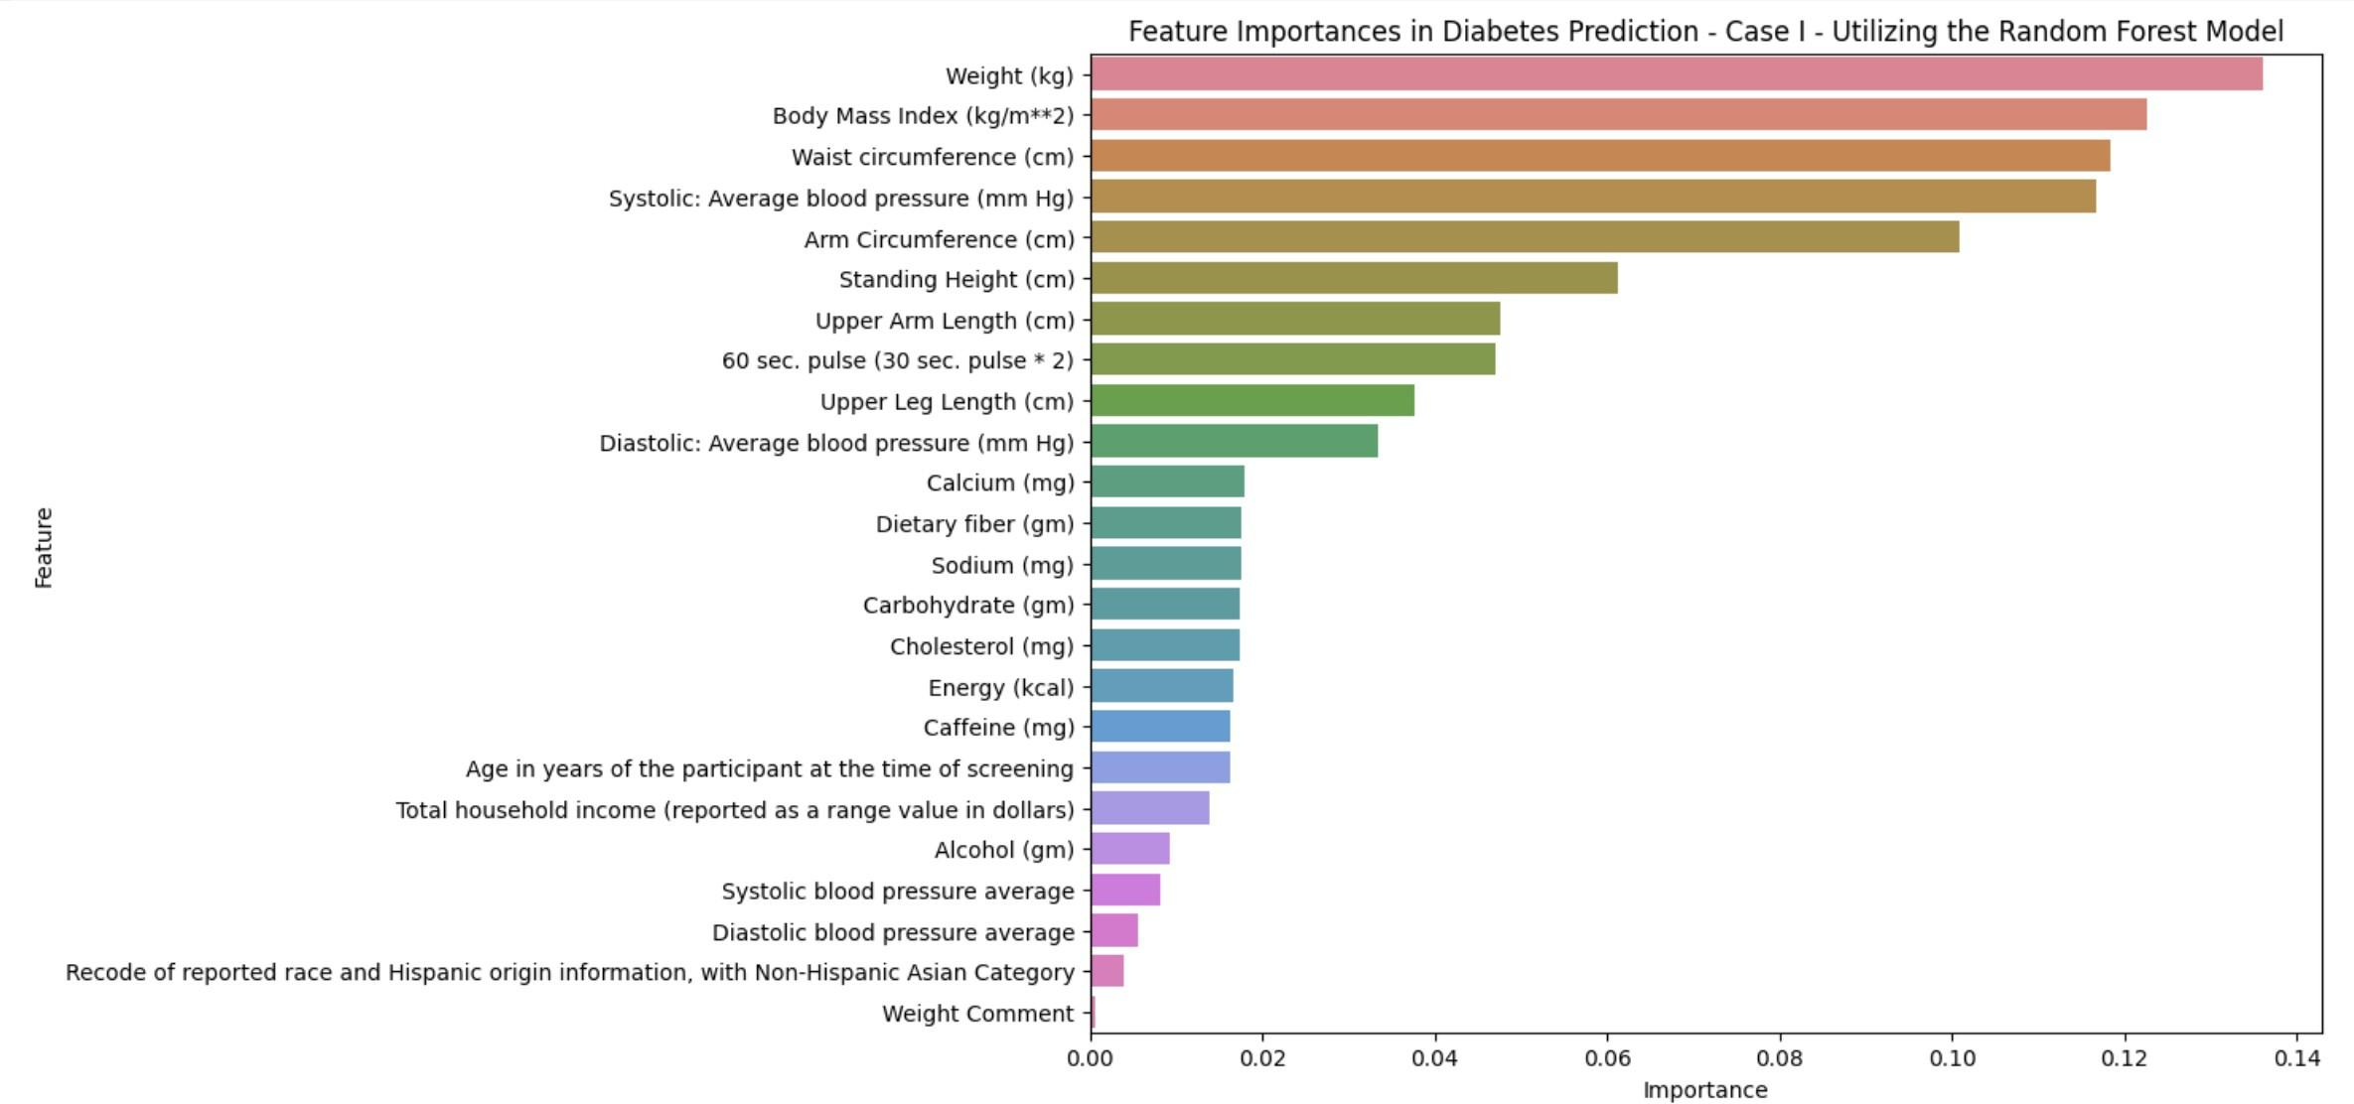

Figure 2
Feature Importance from Random Forest Model for Case I Diabetes Prediction
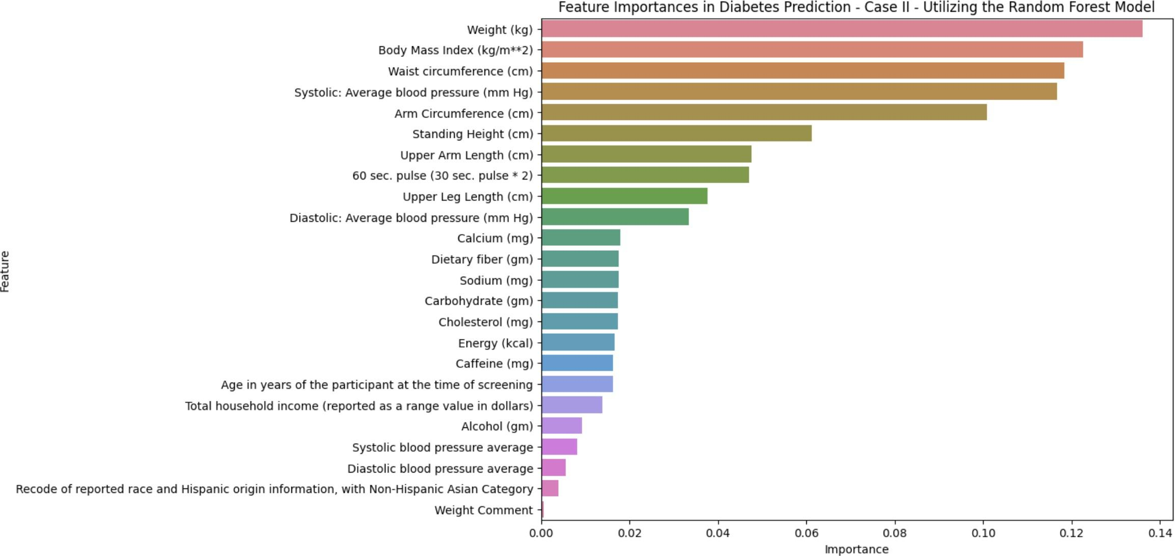

Additional Data Analysis
In addition to the primary analyses, further examination of the dataset revealed noteworthy patterns in various clinical measurements, as illustrated in the following graphs and analyses:

Graph 1: Distribution of Patient Ages
The first histogram represents the distribution of patient ages. The age groups are shown on the x-axis, while the count of patients is on the y-axis. The majority of patients fall within the 0-10 years age group, with exactly 237,559 individuals, suggesting a younger population within the dataset. Following that, there is a noticeable decrease in the number of patients as age increases: 169,919 in the 10-20 years group, 158,110 in the 20-30 years group, and 10,379 in the 30-40 years group. This trend suggests that the dataset includes fewer older individuals, which could be reflective of the general population pyramid or perhaps the sampling methodology of the NHANES dataset. It is also indicative of the potential healthcare needs and resource allocation for pediatric services within the U.S. healthcare system.
The histogram indicates a significant skew in the age distribution of the patient cohort, particularly focusing on those in their 20s and 30s. This concentration of younger age groups may reflect a strategic sampling choice designed to gather data on health and nutritional status during early adulthood. The Centers for Disease Control and Prevention (CDC) emphasizes the importance of such data as younger populations in the U.S. are increasingly facing obesity; this trend towards higher obesity rates at a young age is concerning because it sets the stage for chronic health conditions later in life. By focusing on younger individuals, researchers can gain valuable insights into lifestyle and dietary patterns that contribute to this rise in obesity. Addressing these patterns early on is crucial for the development of public health initiatives and preventative strategies aimed at combating obesity and its associated health risks. The data from younger cohorts in the NHANES dataset thus provide a foundation for understanding and intervening in these trends at a societal level.

Figure 3
Distribution of Patient Ages
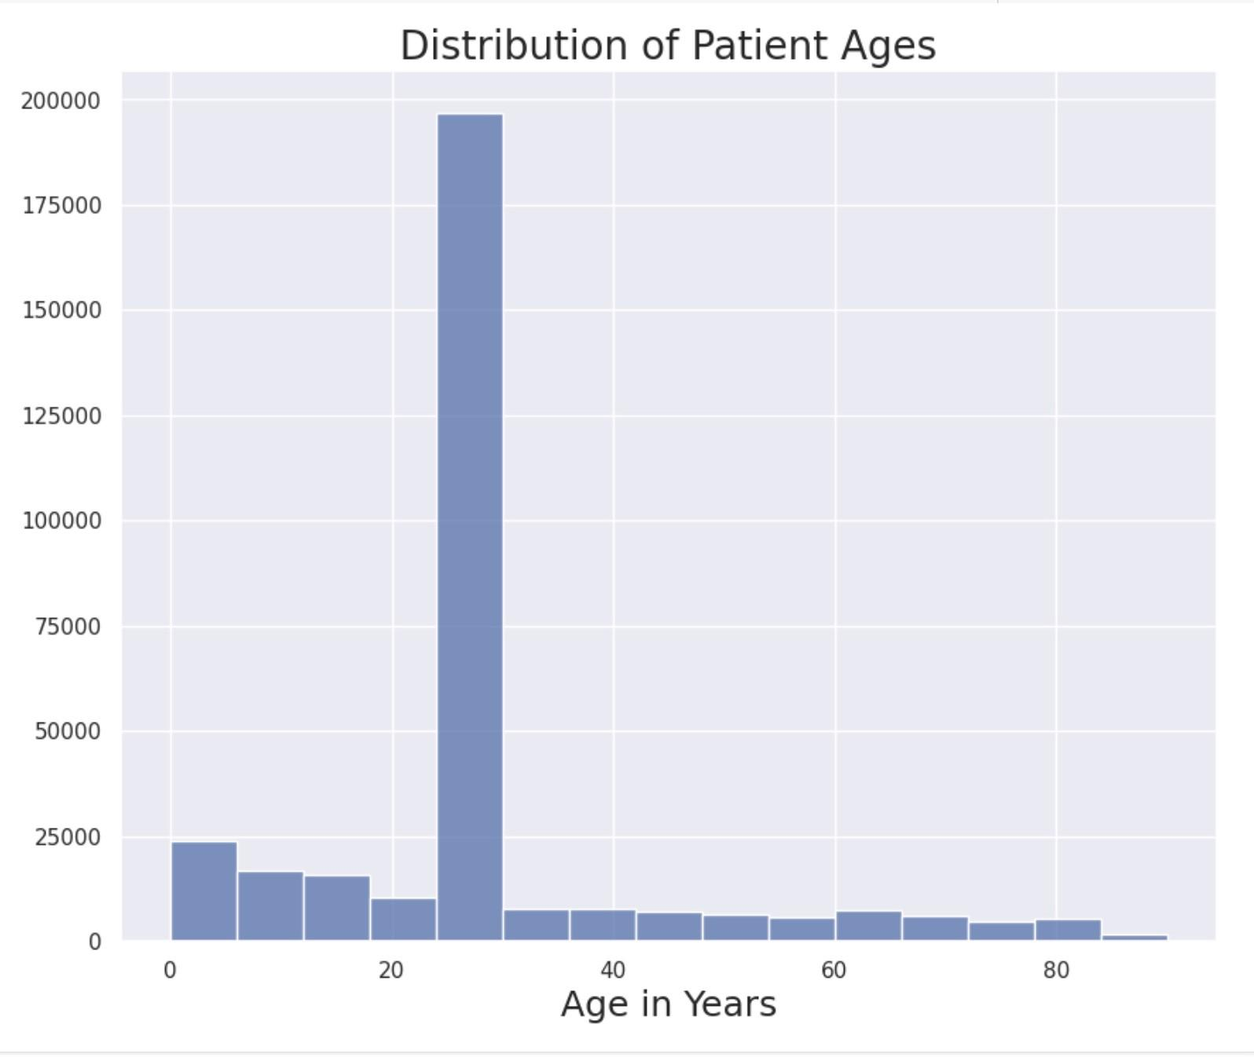

Graph 2: Body Mass Index Distribution Among Diabetic and Non-Diabetic Patients
The second histogram shows the BMI distribution among diabetic and non-diabetic patients. For diabetic patients, the peak is observed at the BMI range of 30-40, with the highest count of 1,821 patients, indicating that the majority of diabetic patients in the dataset are within the obese category according to BMI classifications. This reflects the well-established link between obesity and type 2 diabetes in the real world, underscoring the importance of weight management in diabetes prevention and control.
For non-diabetic patients, the BMI distribution spikes sharply in the normal to overweight range, with the highest count at the 20-30 BMI range with 294,473 individuals. This suggests that within the non-diabetic U.S. population, there is a predominant representation of individuals with a BMI that is considered normal or slightly overweight. This could potentially indicate effective preventative measures against diabetes, or it may reflect the demographic and lifestyle patterns that minimize the prevalence of obesity-related diabetes in this subgroup.

Figure 4
BMI Distribution Among Diabetic and Not Diabetic Patients
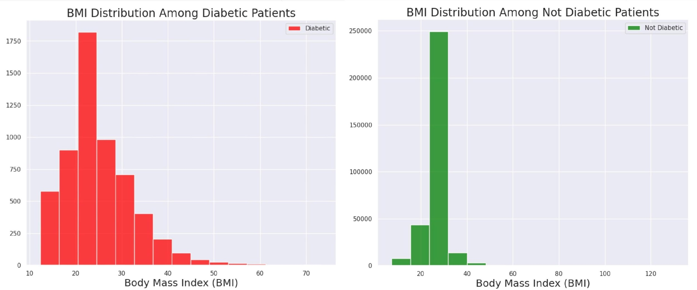

Graph 4: Body Mass Index Distribution Among Undiagnosed and Pre-Diabetic Patients

The fourth histogram displays the BMI distribution among undiagnosed and pre-diabetic patients. The distribution for undiagnosed patients is similar to that of diagnosed diabetic patients, with the highest count at 5,097 in the 30-40 BMI range. This could imply that there is a significant number of individuals who are at risk of diabetes due to obesity but have not yet been diagnosed, highlighting a potential gap in early diagnosis and intervention.
The histogram for pre-diabetic patients shows a similar trend to that of non-diabetic individuals, with a peak count of 278,741 at a BMI range of 20-30. This indicates that while these individuals may not have diabetes, there is a large segment of the population with a BMI that puts them at risk for developing diabetes, pointing to the need for targeted preventive health measures.

Figure 5
BMI Distribution Among Undiagnosed and Pre-Diabetic Patients
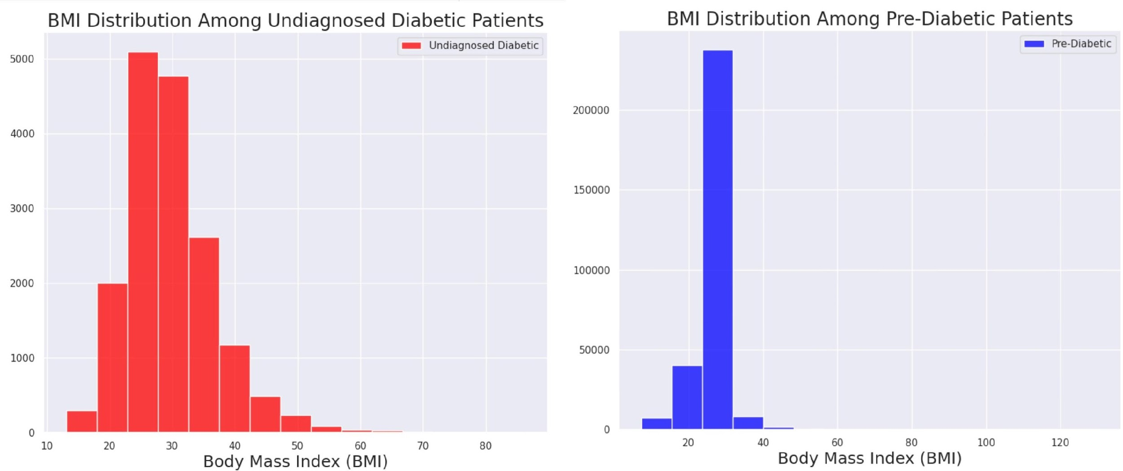

Graph 6: Percent of High, Normal, and Low Blood Pressure Patients Among Different Diabetes Classifications
The bar graph illustrates the percentage of high, normal, and low blood pressure among various diabetes classifications. Notably, 85.78% of pre-diabetic and non-diabetic patients have normal blood pressure, compared to 60.65% of diabetic and undiagnosed diabetic patients. High blood pressure is more common in the diabetic and undiagnosed diabetic group (19.5%) compared to the pre-diabetic and non-diabetic group (8.49%). This illustrates a correlation between diabetes and increased risk of hypertension, a significant real-world health concern, emphasizing the importance of monitoring blood pressure in diabetic care.

Figure 6
Percent of High, Normal, and Low Blood Pressure Patients Among Different Diabetes Classifications
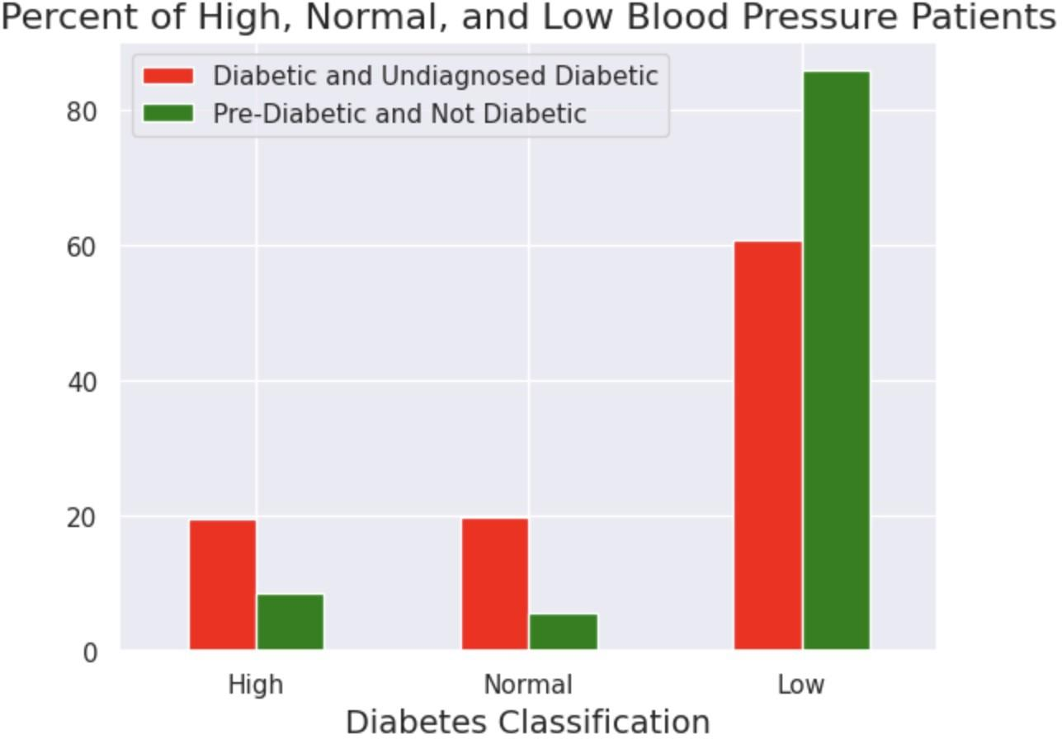

Graph 7: Percent Comparison of Diabetes Classification by Education Level - Cases I and II
The bar graph shown compares the percentage of diabetic classification by education level for cases I and II. For case I, It shows a higher percentage of diabetes in lower education levels, with level 1 education having 3.3% diabetic individuals, which progressively decreases to 3.4% by level 9 education. This suggests an inverse relationship between education level and diabetes prevalence, possibly reflecting socioeconomic factors that influence health outcomes, such as access to education, nutrition, and healthcare resources.
Case II shows a similar trend to Case I, with a notable increase in the percentage of pre-diabetic and undiagnosed diabetic individuals at lower education levels. For instance, level 1 education has 13.4% pre-diabetic and undiagnosed diabetic individuals. This further emphasizes the real-world implications of education on health, particularly on the awareness and management of diabetes.

Figure 7
Percent Comparison of Diabetes Classification by Education Level - Cases I and II
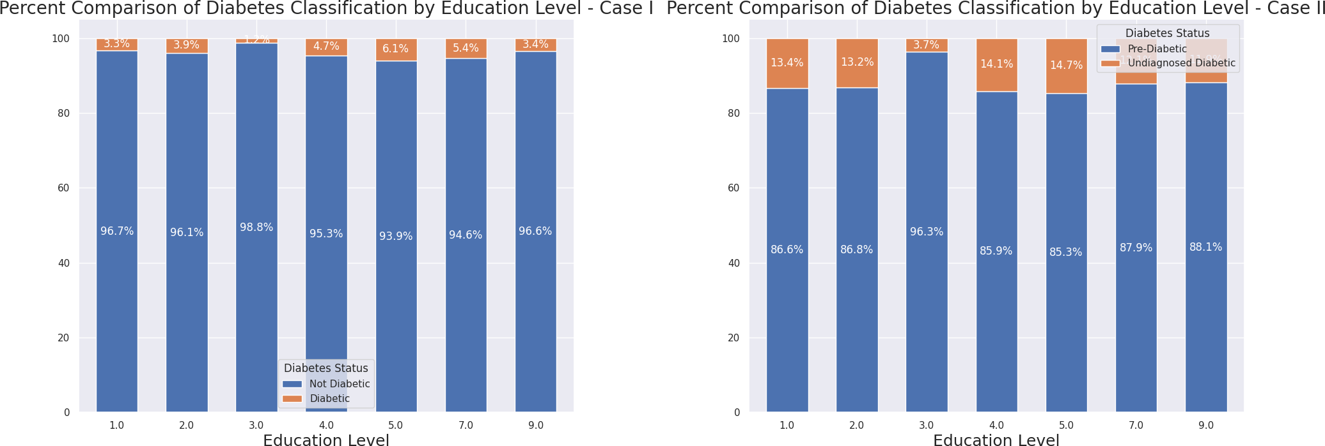

Discussion, Limitations, and Implications
Looking beyond the numbers and results illustrated in Tables 2, 3, and 4, and in Figures 8, 9, 10, and 11 shown below, these results have broader implications for the potential of machine learning in healthcare. The high AUC scores, particularly from the Random Forest and XGBoost models, demonstrate their effectiveness in predicting Type 2 Diabetes using the NHANES dataset. However, it is important to note that further examination is necessary. While the high AUC scores are impressive, they may indicate overfitting. These models need to perform well not only on the training data but also on new, real-world data that is not from the NHANES dataset.
Another notable finding is the consistent performance of the ensemble model across both cases. This suggests that combining the strengths of individual models can lead to strong predictions without the need for additional weights, as also discussed by Semerdjian and Frank (2017), who highlighted the potential of ensemble models in predicting Type 2 Diabetes using NHANES data (Semerdjian and Frank, 2017).
Moving forward, the study recommends exploring other ensemble techniques and delving deeper into the intricacies of each individual model. Additionally, harnessing more data, potentially from different demographics or wider timeframes, could enhance the predictive capabilities. Real-world testing of the models on diverse datasets beyond NHANES data is crucial to assess their applicability and robustness.
While it is essential to incorporate additional outside data to test the model, the study’s leveraging of the NHANES survey to explore not only the prevalence of Type II Diabetes but also its incidence, particularly across different age groups, genders, and racial/ethnic demographics proves invaluable. This approach provides a robust framework for understanding how the disease affects diverse populations, which is crucial for tailoring effective, targeted interventions.
To further illustrate the points made, the following statistics from the NHANES dataset detail the incidence of Type II Diabetes in the U.S. population, breaking it down by age, gender, and ethnicity. These figures have been sourced from the Centers for Disease Control and Prevention’s National Diabetes Statistics Report (Centers for Disease Control and Prevention, 2023), providing a detailed picture with a 95% Confidence Interval (CI): the incidence rates are 3.0, 10.1, and 6.8 per 1,000 people for the age groups 18-44, 45-64, and 65 years or older, respectively. Gender-specific rates are 6.4 (male) and 5.5 (female) per 1,000. Ethnically, the rates are 5.1 (White, non-Hispanic), 6.8 (Black, non-Hispanic), 3.8 (Asian, non-Hispanic), and 6.1 (Hispanic) per 1,000. From these statistics, several conclusions emerge:
- Approximately 1.2 million new cases of diabetes, equating to an incidence rate of 5.9 per 1,000 people, were diagnosed.
- Incidence rates of diagnosed diabetes are higher among adults aged 45 to 64 years and those aged 65 years and older compared to adults aged 18 to 44 years.
- Non-Hispanic Black adults and Hispanic adults exhibit higher incidence rates compared to non-Hispanic White and Asian adults.
It is important to note that while these statistics are sourced from the CDC and based on the NHANES dataset, they have not been further analyzed within the scope of this study — a limitation that underscores an area for future research.
Despite this limitation, the incorporation of machine learning techniques in predicting Type II Diabetes has significant implications in the medical field, particularly in enhancing early diagnosis and personalized treatment strategies. Machine learning models, including those developed from large datasets like NHANES as done in this paper, can analyze vast amounts of data and identify complex patterns that may not be evident through traditional statistical methods. For instance, the ability of these models to accurately predict new, unseen validation data, as highlighted by the works of Chen and Lin (2006) and Yu et al. (2010), provides a useful way for medical professionals to generalize for incoming batches of data, which can significantly improve diagnosis and treatment strategies (Chen and Lin, 2006, et al., 2010).
Furthermore, while this study focused on Type 2 Diabetes, the methodologies and insights could potentially be adapted to predict other medical conditions, expanding the scope of this research. The consistent performance across models indicates a reliable approach that can be replicated in other domains with appropriate modifications.
Lastly, interdisciplinary collaboration is essential in such endeavors. Combining the expertise of healthcare professionals with data scientists can lead to more refined, accurate, and clinically relevant prediction tools. This collaboration ensures that the models, while mathematically sound, also align with clinical realities and patient needs.
In conclusion, this research represents a significant step forward in utilizing machine learning for healthcare predictions. By comparing and evolving methodologies, and achieving impressive results, it paves the way for further advancements in this rapidly evolving field. However, there is still much to explore, refine, and innovate in order to fully harness the potential of machine learning in healthcare predictions.

Table 2
Model Evaluation Metrics Using Laboratory Data for 1988-2018 Diabetes Case I

Model | ROC-AUC | Precision | Recall | F1
Logistic Regression | 0.66249 | 0.685279 | 0.593407 | 0.636042
SVM | 0.837121 | 0.891093 | 0.771564 | 0.827032
Random Forest | 0.865298 | 0.791189 | 0.986813 | 0.878240
XGBoost | 0.856807 | 0.848593 | 0.958699 | 0.900292
KNN | 0.770757 | 0.805371 | 0.939560 | 0.866261
Decision Tree | 0.787921 | 0.791713 | 0.776923 | 0.784248
Naive Bayes | 0.526486 | 0.859197 | 0.818348 | 0.830490
Ensemble | 0.859822 | 0.788308 | 0.978022 | 0.872977

Table 3
Model Evaluation Metrics Using Laboratory Data for 1988-2018 Diabetes Case II

Model | ROC-AUC | Precision | Recall | F1
Logistic Regression | 0.737103 | 0.873745 | 0.827120 | 0.849793
SVM | 0.851885 | 0.756021 | 0.793407 | 0.774263
Random Forest | 0.891081 | 0.852442 | 0.880482 | 0.866235
XGBoost | 0.892435 | 0.859089 | 0.944810 | 0.899913
KNN | 0.861592 | 0.824221 | 0.808482 | 0.866235
Decision Tree | 0.830526 | 0.849997 | 0.813848 | 0.830490
Naive Bayes | 0.783171 | 0.592518 | 1.000000 | 0.675074
Ensemble | 0.873427 | 0.869737 | 0.883406 | 0.876519

Table 4
Model Evaluation Metrics Using Test Data - Cases I and II

Model | Case | ROC-AUC | Precision | Recall | F1
Logistic Regression | I | 0.6768 | 0.7070 | 0.5780 | 0.6360
SVM | I | 0.8846 | 0.7839 | 0.8769 | 0.8278
Random Forest | I | 0.9990 | 0.9468 | 0.9978 | 0.9716
XGBoost | I | 0.9834 | 0.8196 | 0.9934 | 0.8982
KNN | I | 0.9042 | 0.7931 | 0.8549 | 0.8228
Decision Tree | I | 0.9334 | 0.8266 | 0.9692 | 0.8923
Naive Bayes | I | 0.8312 | 0.5101 | 1.0000 | 0.6756
Ensemble | I | 0.9772 | 0.8135 | 0.9967 | 0.8958
Logistic Regression | II | 0.8723 | 0.8919 | 0.7752 | 0.8295
SVM | II | 0.9270 | 0.8711 | 0.8988 | 0.8847
Random Forest | II | 0.9737 | 0.8706 | 0.9759 | 0.9202
XGBoost | II | 0.9588 | 0.8615 | 0.9547 | 0.9057
KNN | II | 1.0000 | 1.0000 | 1.0000 | 1.0000
Decision Tree | II | 0.9650 | 0.8849 | 0.9638 | 0.9227
Naive Bayes | II | 0.8984 | 0.8638 | 0.6795 | 0.7606
Ensemble | II | 0.9806 | 0.9090 | 0.9459 | 0.9271

Figure 8
ROC Curve for Case I
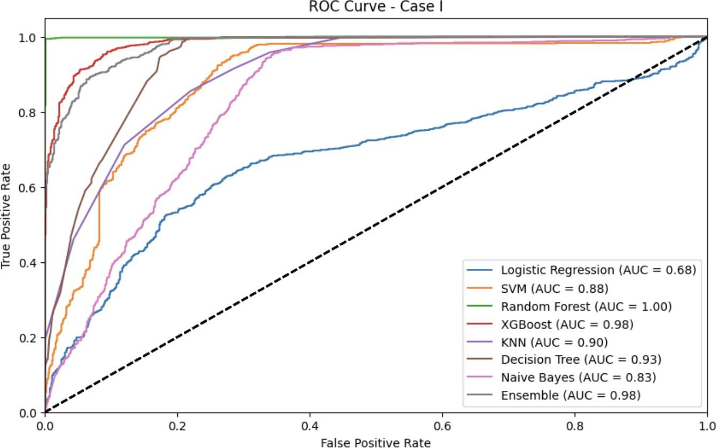

Figure 9
ROC Curve for Case II
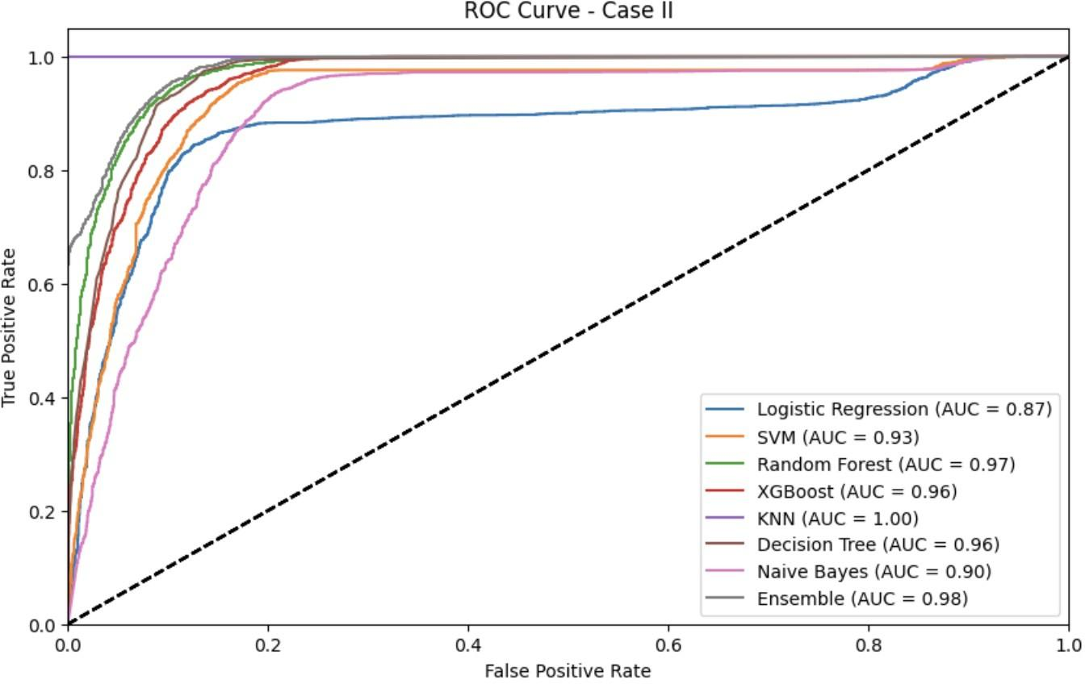

Figure 10
Confusion Matrix Analysis for Test Dataset Evaluation in Case I
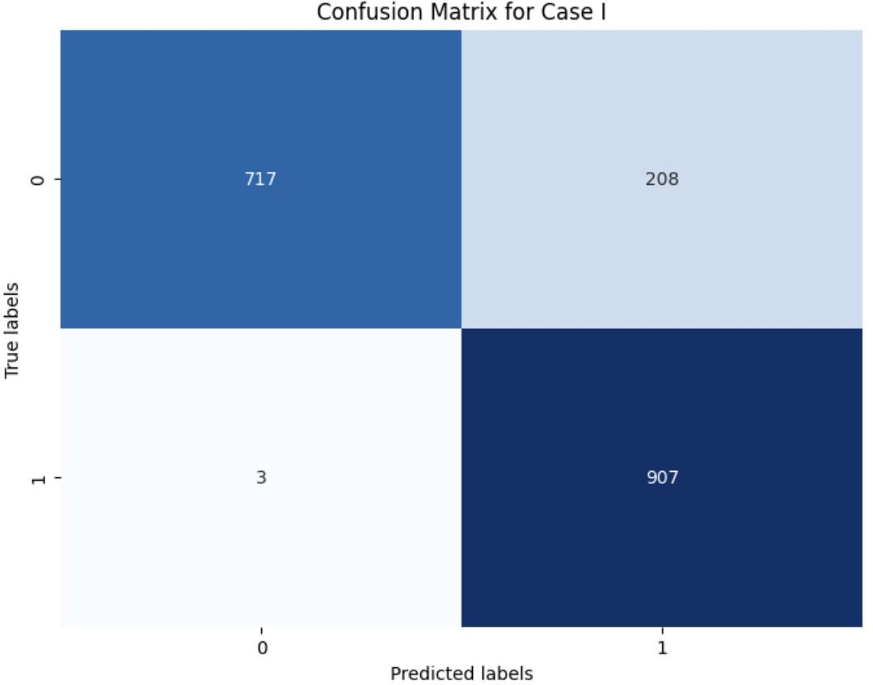

Figure 11
Confusion Matrix Analysis for Test Dataset Evaluation in Case II
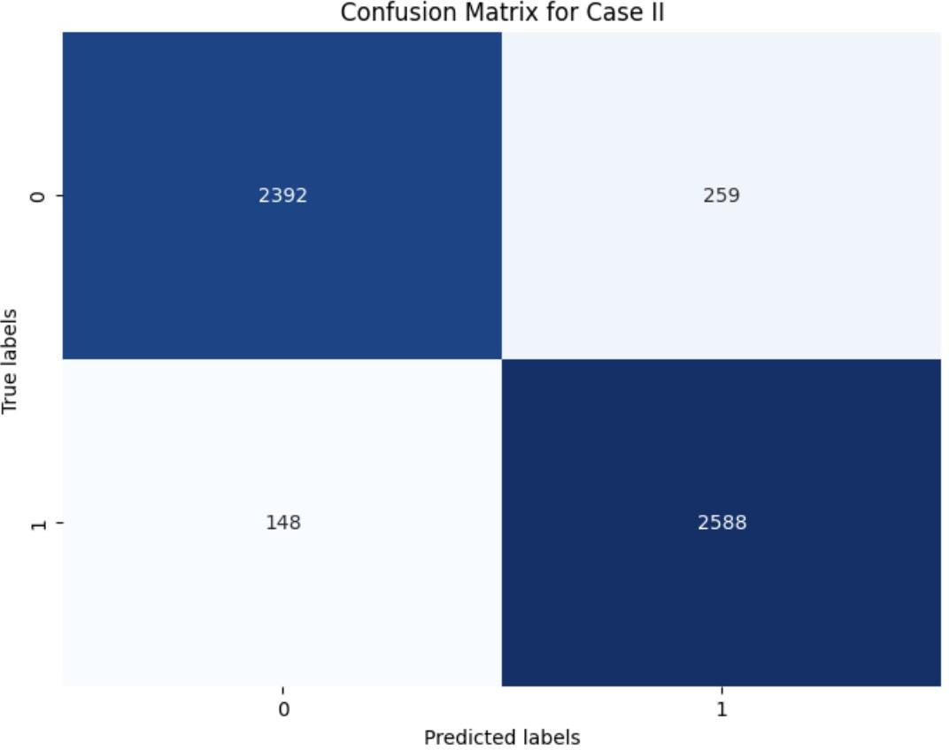

Acknowledgements
The author would like to express sincere gratitude to mentor Mr. Hamid Abuwarda for his invaluable guidance and support throughout the research process. Mr. Abuwarda’s insightful feedback and perspectives greatly enhanced the quality of this study.

References
Centers for Disease Control and Prevention. (2023). National diabetes statistics report [Accessed: Apr. 15, 2024]. Retrieved April 15, 2024, from https://www.cdc.gov/diabetes/data/statistics-report/index.html#anchor_63700
Centers for Disease Control and Prevention. (n.d.). Nhanes survey methods and analytic guidelines [Accessed: Apr. 15, 2024]. Retrieved April 15, 2024, from https://wwwn.cdc.gov/nchs/nhanes/analyticguidelines.aspx#plan-and-operations
Chatterjee, S., Khunti, K., & Davies, M. J. (2017). Type 2 diabetes. Retrieved September 29, 2023, from https://somepomed.org/pdf/abril/Type-2-Diabetes-2017.pdf
Chen, Y.-W., & Lin, C.-J. (2006). Combining svms with various feature selection strategies. In Feature extraction. Springer. Retrieved September 29, 2023, from https://link.springer.com/chapter/10.1007/978-3-540-35488-8_13
Dinh, A., Miertschin, S., Young, A., & Mohanty, S. D. (2019). A data-driven approach to predicting diabetes and cardiovascular disease with machine learning. BMC Medical Informatics and Decision Making. Retrieved September 29, 2023, from https:
//bmcmedinformdecismak.biomedcentral.com/articles/10.1186/s12911-019-0918-5 et al., W. Y. (2010). Application of support vector machine modeling for prediction of
common diseases: The case of diabetes and pre-diabetes. BMC Medical Informatics and Decision Making, 10 (16). Retrieved September 29, 2023, from https:
//bmcmedinformdecismak.biomedcentral.com/articles/10.1186/1472-6947-10-16 Heredia-Langner, A., Jarman, K. H., Amidan, B. G., & Pounds, J. G. (2013). Genetic
algorithms and classification trees in feature discovery: Diabetes and the nhanes database. Proceedings of the International Conference on Data Mining (DMIN), 1.
National health and nutrition examination survey (nhanes). (n.d.). Office of Disease PreventionHealth Promotion, U.S. Department of HealthHuman Services. Retrieved September 29, 2023, from
https://health.gov/healthypeople/objectives-and-data/data-sources-and- methods/data-sources/national-health-and-nutrition-examination-survey-nhanes
Semerdjian, J., & Frank, S. (2017). An ensemble classifier for predicting the onset of type ii diabetes. arXiv. Retrieved September 29, 2023, from https://arxiv.org/abs/1708.07480
Shmueli, G. (2010). To explain or to predict? Statistical Science, 25 (3). Retrieved September 29, 2023, from https://projecteuclid.org/journals/statistical- science/volume-25/issue-3/To-Explain-or-to-Predict/10.1214/10-STS330.full
Teimouri, M., & Alavinia, M. (2015). Comparison of various classification algorithms in the diagnosis of type 2 diabetes in iran. International Journal of Diabetes in Developing Countries. Retrieved September 29, 2023, from https://www.researchgate.net/publication/277634174_Comparison_of_various_ classification_algorithms_in_the_diagnosis_of_type_2_diabetes_in_Iran

