Leonardo da Vinci’s study of light and optics: A synthesis of fields in The Last Supper

Nicole Bitler

Stanford University

Correspondence concerning this article should be sent to Nicole Bitler. Email: nbitler@stanford.edu
Leonardo da Vinci’s Milanese observations of optics and astronomy complicated his understanding of light. Though these complications forced him to reject “tidy” interpretations of light and optics, they ultimately allowed him to excel in the portrayal of reflection, shadow, and luminescence (Kemp, 2006). Leonardo da Vinci’s The Last Supper demonstrates this careful study of light and the relation of light to perspective. In the work, da Vinci delves into the true complications of optics and reflections, and its renown guided the artistic study of light by subsequent masters. From da Vinci’s personal manuscripts, accounts from his contemporaries, and present-day art historians, the iterative relationship between Leonardo da Vinci’s study of light and study of optics becomes apparent, and how his study of the two fields manifested in his paintings.
Upon commencement of courtly service in Milan, da Vinci immersed himself in a range of scholarly pursuits. Da Vinci’s artistic and mathematical interest in perspective led him to the study of optics. Initially, da Vinci “accepted the ancient (and specifically Platonic) idea that the eye functioned by emitting a special type of visual ray” (Kemp, 2006). In his early musings on the topic, da Vinci reiterated this notion, stating in his notebooks that, “the eye transmits through the atmosphere its own image to all the objects that are in front of it and receives them into itself” (Suh, 2005). Leonardo da Vinci’s early thoughts on light and reflections demonstrate his acceptance of conventional theories on optics and the functioning of the eye. In similar fashion, da Vinci took for granted the paradigm of Alberti’s visual pyramid “as a fundamental doctrine in the science of art” (Kemp, 2006). In his early studies of optics, da Vinci absorbed the work of his predecessors, taking their often erroneous theories as truth.
Spurred by an interest to incorporate a mathematical study of optics in one of his texts, da Vinci further investigated the field and questioned previously held understandings. Da Vinci was unable to accept the imperfect theories of his predecessors that conflicted with his observations of the natural world. Leonardo’s success lies not in his ability to accurately perceive all physical and natural phenomena, but to discern between those of greater truth from those of lesser truth.
Leonardo’s careful study of the nature of light, which manifested in both his astronomical study and his optical study, caused him to question the beliefs to which he had ascribed. Because of his observations and experimentations with light and optics, Leonardo da Vinci, by 1492, began to “accept the overwhelming arguments to the contrary [of the pyramidal theory], arguments expressed by Alhazen, Witelo, and Pecham, to the effect that the primary mechanism of vision was the reception (intromission) of light rays from objects into the eye” (Kemp, 2006). Da Vinci’s rejection of previously held beliefs placed him in conversation with optical scholars of his day.
Leonardo da Vinci translated his experiments involving optics to an understanding of visual trickery and a “realization of the eye’s propensity for deception” (Kemp, 2006). Leonardo da Vinci’s early foray into scientific thought demonstrated his methodological and practiced approach to science and adherence to the belief that observation of the natural world was supreme-that a scientist could accurately perceive the physical phenomena of the earth by seeing them. Da Vinci’s “realization” caused him to refute his early interpretations of the “tidy identification between seeing and knowing” (Kemp, 2006). Da Vinci’s leap from a purely practical and tangible view of the inner workings of the world to an abstract and somewhat convoluted one challenged concrete understandings of earthly properties.
Concurrent with his critique of optics, da Vinci developed a keen interest in the properties of light inherent in planetary relationships. Leonardo’s preoccupation with astronomy and planetary reflection led him to greater understanding about the complexities of light. Though Leonardo da Vinci “was well aware of the Ptolemaic tradition” and theories of planetary movements of his day, he tended away from questions of mathematical astronomy and motions of the planetary bodies, preferring rather to study the “visual perception of the heavenly bodies, so that his astronomy may not unfairly be described as the handmaiden to his optics” (Clark, 1998). We can see da Vinci attempting to marry the two fields, giving credence to his scientific and artistic notions on vision and light. In thoughts on astronomical reflection, he uses language characteristic of optical pyramidal theory, that a “shadow is like a pyramid which grows as it recedes and of which the length has no end…or can [resemble] a pyramid and comes to an end, as is seen in the eclipses of the moon” (Suh, 2005). This demonstrates that da Vinci was considering these areas of scholarly pursuit in tandem.
Leonardo da Vinci, like Brunelleschi, experimented with perspective, but with an emphasis on light. Through this experimentation he developed greater understanding about the reflection of the sun’s light on the planets. Da Vinci directs his audience to replicate his study, stating, “If you want to see how much brighter the shaded portion of the Moon is than the background on which it is seen, conceal the luminous portion of the Moon with your hand or with some other more distant object” (Suh, 2005). Da Vinci examines both what is seen and what is unseen in the physicality of planetary movements. He disassociated himself from a need to fit each observation perfectly within a theoretical framework, allowing himself to explore his observations and develop a better sense the physical nuances of planetary motion.
Leonardo’s experimentation led him to accurately describe astronomical theories on the relationship of the sun’s light to the planets, which aided in his study of perspective. In particular, da Vinci was interested in “the transmission of light from one planetary body to another” (Kemp, 2006). He focused on the visual implications of astronomical phenomena and used the planets as a case study of perspective. Martin Kemp comments, “the planets and the world were, for Leonardo, reflective balls of variegated earth and water, borrowing radiance from the marvelous sun” (Kemp, 2006). Leonardo applies these observations of the planets to his understanding about refraction and reflection. He characterizes sources of light and sources of shadow in his notebooks, pointing out how and where light originates, and the gradients of lightness and darkness. With observation that “the place will be most luminous from which the greatest number of luminous rays are reflected,” da Vinci carries his scientific experimentation of light to his art, particularly of the human face (Suh, 2005). Da Vinci considers the ways in which the rays of light cause differential illumination of the face and gives his “proof and reason why among the illuminated parts certain portions are in higher light than others” (Suh, 2005). In his notebook, da Vinci depicts the rays of light contacting the face at various angles, causing differential illumination and shadow. Da Vinci applied his calculated mathematical understanding of optics to his art, enhancing the accuracy of the dimensionality in his paintings.
Though da Vinci had been particularly skillful in his use of shadow and chiaroscuro before his rejection of archetypal ideas of optics and acquired knowledge of refraction, his subsequent paintings were deepened by the knowledge of the vast complexities of light and the eye’s perception. Into his paintings, da Vinci wove his sagacity of perspective and light through tedious calculation and draft. Throughout his career, da Vinci showcased his preoccupation with light and shadowing through mastery of the art of chiarosuro. The development of his technique of capturing the “unity of shadow, progressively veiling the boundaries of different colour areas” was one of Leonardo’s great early accomplishments and won him substantial favor as a young artist (Kemp, 2006). However, his earlier works were often overly “concerned with the objective recording of reality” (Marani, 2003). The preoccupation with capturing reality in his early paintings was not yet substantiated by the knowledge of light’s refraction.

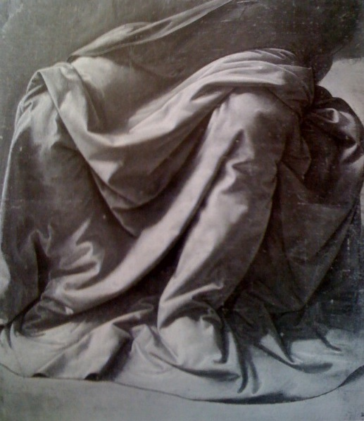
Figure 1: Leonardo da Vinci’s drapery study shows his dexterity with chiaroscuro, the use of lightness and darkness to give depth and physicality to a piece. The study is housed in the Musee du Louvre, Paris (Marani, 2003).

The shift from an emphasis on pure objectivity to the intangible nuances of color and light can be seen in his two depictions of The Virgin of the Rocks. His later rendition of the subject, painted in the 1490s, “demonstrates an evolution in Leonardo’s painting that is reflected in his theoretical writings” (Marani, 2003). In the progression of his work, “more and more attention is paid to the evocation of the impression of light upon objects and less to the linear description of their actual form” (Kemp, 2006).

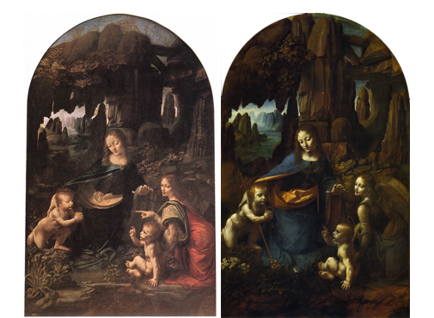
Figure 2: Leonardo da Vinci’s two versions of Virgin of the Rocks. The work on the left was painted from 1483 to 1486 and is currently housed in the Musee du Louvre, Paris. The work on the right was painted from 1495 to1508 and is currently housed in the National Gallery, London (Web Gallery of Art).

The Last Supper is da Vinci’s capolavoro in its meticulous exploration of light and optics and the careful rendering of the figures casting shadows upon one another. Leonardo da Vinci not only attends to the refraction and reflection of light, but also considers the imperfections inherent in optical perception of the piece. The Last Supper “embodies Leonardo’s longstanding preoccupation with the science of optics and acoustics…portraying…the outward movement” (Marani, 2003). Described as “the summa” and the “climax of Leonardo’s career as a painter,” da Vinci’s masterpiece brings forth a particularly inspired luminosity (Marani, 2003; Clark, 1988).
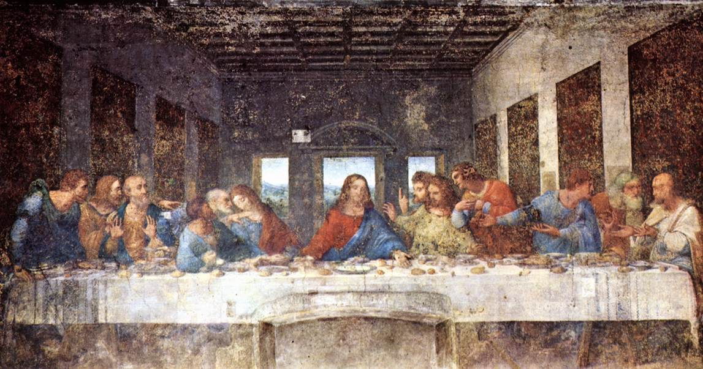
Figure 3: Leonardo da Vinci’s The Last Supper, painted in 1498 and housed in the Convent of Santa Maria delle Grazie, Milan (Web Gallery of Art).

In his notebooks, da Vinci describes the figures in concert, commenting, “another lays his hand on the table and is looking. Another blows [air out of] his mouth. Another leans forward to see the speaker shading his eyes with his hand. Another draws back behind the one who leans forward, and sees the speaker between the wall and the man who is leaning” (Suh, 2005). Da Vinci’s concern with proportion and placement of figures and their influence on shadow and illumination is a subject addressed in his notebooks. He states, “all bodies, in proportion as they are nearer to, or farther from, the source of light, will produce longer or shorter derived shadows” (Suh, 2005). Hence, da Vinci translates his arrangement of figures into an interpretation of the movement of light in the painting.
The innovations of light and optics extend beyond the characters in The Last Supper, influencing the future art of still life. The careful attention to the refraction of light on the inanimate objects in the scene makes Leonardo one of the first masters of still life. In calculating the positioning and refraction of the light rays, each object must be placed within its optical context. Pietro Marani (2003) finds that “Leonardo’s scientific interest in the representation of…objects subjected to the play of light and reflections (such as those on the table in The Last Supper) also had an immediate impact on artists.” Marani (2003) goes on to describe the likely influence that this attention to detail had on future artists. He states, “We imagine, for example, that the young Caravaggio must have admired Leonardo’s careful observation and objective…and the still life in The Last Supper.” From the food on the table to the tablecloth, “reproduced so well that Rheims linen itself would not appear more real,” da Vinci leaves no detail involving light and reflection unaccounted (Vasari, 1991). Despite the breakdown of the materials following the creation of this piece, Vasari writes at a time when the al fresco painting would have been perfectly intact. The grace and elegance with which da Vinci threads light in every moment and breath of The Last Supper accentuate his refined knowledge on the subject.
The painting was an instant classic and its popularity spread quickly. Nearly a contemporary of da Vinci, Vasari (1991) confirms that the The Last Supper had “always been held in the greatest veneration by the Milanese and by foreigners as well.” Vast numbers of princes, noblemen, artists, and foreigners alike would have traveled to Milan to view the great work and share in its superb rendition of the parable. The nearly ubiquitous knowledge of the piece among the art community had a profound effect on future artists. Pietro Marani (2003) reiterates that the painting influenced Rembrandt and Rubens in the north and that his “naturalism and the remarkable truthful still life” influenced artists in the south as well. But of course his work touched not only subsequent artists, but the entire field of painting. Vasari (1991) heralds da Vinci’s capolavoro by pronouncing that, “to the art of painting he added a kind of shadowing to the method of colouring with oils which has enabled moderns to endow their figures with great energy and relief.” In the short time between Leonardo da Vinci’s death and Vasari’s description in his The Lives of the Artists, recapitulates the profundity of his contribution.
The Last Supper represents a lifetime of scholarly pursuit in the fields of optics and light. The Last Supper is one of the only of da Vinci’s paintings for which we see in his notebooks such a careful attention to the composition and the reflection of light, in sketches and notes, particularly related to the positioning of figures. Da Vinci makes clear note of the spatial arrangement of characters, which was particularly important in determining the reflection and refraction of light among figures and objects. As part of his study for the piece, da Vinci likely outlined the movement of the rays of light in perspective, how each ray caused illumination and shadow on the faces of the characters, and how the shadows cast from inanimate objects were connected with the refraction of those rays. The Last Supper is a masterpiece because in it is woven a vast knowledge of refraction, developed through observation, experimentation, and an interdisciplinary approach to optics and light. By challenging the assumptions of his day, da Vinci stood apart from his contemporaries, pioneering the use of light and optical theory in art. Had it not been for da Vinci’s relentless musings on the subjects of optics and light, individually and in tandem, The Last Supper, and many of his other later pieces, may have lacked the luminosity for which they are praised. It is a success in both relational elements between figures and still life as a result of da Vinci’s patience and painstaking preoccupation with every ray of light and every shadow. His ability to also pioneer the field of still life rested upon his ability to account for the interconnectedness of light touching all figures, objects, natural landscapes, and architectural features.
Inspired by a scientific and mathematical interest in optics and astronomical theory, Leonardo da Vinci refined his early conceptions of optical theory by means of observation and experimentation. Through optics da Vinci challenged the visual theories of his contemporaries and through astronomy he gained a more nuanced view on the refractive and reflective qualities of light. Da Vinci incorporated his enhanced understanding of visual perception and the perspective of light into his paintings. The Last Supper is a masterpiece in its agile synthesis of scientific theory and concert of aesthetic technique. Leonardo da Vinci furthered the field of painting and encouraged a dedication to the truth of lighting among subsequent artists.

References

Clark, K. Leonardo da Vinci. (1988). New York, NY: Penguin Books.
Kemp, M. Leonardo da Vinci: The Marvellous Works of Nature and Man. (2006). New York, NY: Oxford University Press.
Marani, P. Leonardo da Vinci: The Complete Paintings. (2003). New York, NY: Harry N. Abrams, Inc.
Suh, H. A. Leonardo’s Notebooks. (2005). New York, NY: Black Dog & Leventhal Publishers.

Vasari, G. The Lives of the Artists. (1991). Oxford: Oxford University Press.

Web Gallery of Art. (2010). Retrieved June 25, 2010 from http://www.wga.hu/index.html.

