Intersect, Vol 14 No 1 (2020)

Recycling and Reusing Carbon Dioxide: A Solution to Global Warming

Ramaya Vishwanath
University of Delhi, Department of Chemistry

Abstract
The world is at the brink of a catastrophe. Climate change via global warming is threatening to destroy the planet, which has existed for the last 4.5 billion years and been home to humans for 6 million years. The warning signs are glaring, urging humans to try and undo the excessive harm that we have inflicted upon the planet. Yet, a large population remains indifferent to the disastrous implications. If we hope to thrive for many more centuries, we must step up, educate ourselves and turn into environmentally-conscious and environmentally-friendly citizens. A silent killer, global warming has dire implications for our planet’s future. It cannot be reiterated enough that if we do not act now, there may be no future for our planet. In the following article, I consider the solutions to only one aspect of climate change- global warming due to the greenhouse effect. The most wide-spread greenhouse gas responsible for global warming is carbon dioxide. Carbon dioxide plays a dual role in the atmosphere: an optimum amount of carbon dioxide in the air is essential to ensure life on Earth, yet a surplus of it promotes global warming. This article seeks to elaborate upon the main chemical methods by which the concentration of excess carbon dioxide can be mitigated: recycling of carbon dioxide by electrochemical processes, reusing of carbon dioxide in its transcritical state, and converting carbon dioxide into biomass.

Introduction
Global warming has caused the average temperature of the planet to rise by a little more than 1°C. This number might seem tiny, but it has several significant consequences- glaciers have begun to melt, rivers have started to disappear, the sea level may rise by more than a meter by 2100 (Watts, 2020), mountainous regions will begin experiencing more landslides, several living species may face extinction (already more than 32,000 species are threatened with extinction according to the IUCN red list) and the list does not end here. These consequences, while pressing, may seem distant and thus, less threatening to the average individual. However, with each passing day, the dangers of global warming have grown and expanded- they are now knocking at our doors. As of today, global warming is responsible for 150,000 human deaths every year, a number that is expected to double by 2030. Apart from deaths, global warming will also cause several dire health consequences. Erratic climatic conditions could impact water-borne diseases and ailments transmitted via insects, snails and other animals. Scientists believe that global warming could even lead to changes in disease vectors. The common vector-borne diseases include malaria, dengue, chikungunya, and the more recently discovered Zika virus. Climate change may cause a shift in the method of transmission of these diseases, and may even lead to the re-emergence of some vector-borne diseases thought to be eradicated. (Githeko, Lindsay, Confalonieri, & Patz, 2000) Apart from this, the ramifications of global warming may even be seen on the social and economic determinants of health; the availability of clean drinking water may decrease due to reasons such as irregular drought-flood cycles, agricultural production may be impacted due to fluctuations in the weather, and clean air will become increasingly scarce.
The greenhouse effect has been recognized as the primary cause of global warming. In general, the greenhouse effect causes the natural warming of the Earth and therefore is a necessary process to ensure continuity of life. About one-third of the sun’s radiation hitting Earth’s atmosphere is reflected into space by clouds, ice, snow, sand and other reflective surfaces. The other two-thirds is absorbed by the Earth’s surface and the atmosphere. As the land, oceans and atmosphere heat up, they re-emit the energy as infrared thermal radiation, which passes through the atmosphere. Heat-trapping gases like carbon dioxide (CO₂) absorb the infrared radiation and prevent it from dissipating into space, giving rise to the greenhouse effect. An increase in the concentration of greenhouse gases like water vapour, carbon dioxide, methane and chlorofluorocarbons (CFCs) in the atmosphere has increased the intensity of the greenhouse effect. Consequently, this has led to the significant warming of the planet.

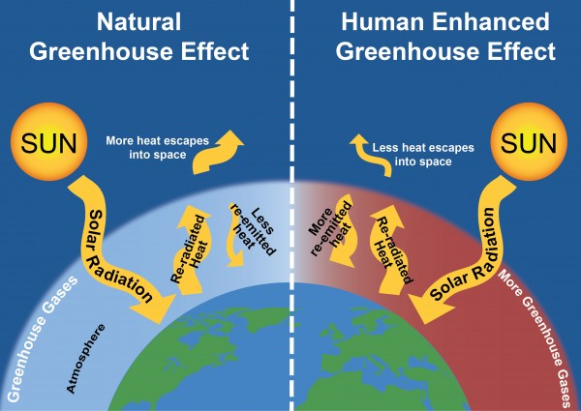
FIGURE 1: The Greenhouse Effect (Centre for Sustainable Systems, 2020)

Several human activities are responsible for the release of greenhouse gases. Burning of fossil fuels, clearing of forest and agricultural land, and vehicular pollution release CO₂ in the air, far beyond the permissible limit. Emissions from air-conditioners release CFCs and industrial emissions liberate a host of greenhouse gases. According to a 2018 article by the World Economic Forum, carbon dioxide emissions have reached their highest level in 8 million years. Out of all the greenhouse gases, carbon dioxide is the most common, and thus, a pivotal path to combating global warming is by reducing our carbon emissions. While carbon dioxide is a vital atmospheric constituent and plays an integral role in several phenomena, such as photosynthesis and respiration, to ensure the sustainability of the environment, carbon dioxide levels should be balanced. Globally, we emit over 36 billion tonnes of carbon dioxide annually, which is an alarmingly colossal figure. For a long time, scientists have been focused on finding alternative renewable sources for fossil fuels, a primary cause for CO₂ emissions. These scientists are convinced that if we were to reduce our fossil fuel consumption, the amount of carbon dioxide in the air would automatically decrease. However, few members of the scientific community agree. They state that even if fossil fuel consumption were to decline, the amount of carbon dioxide in the air would continue to increase steadily. Data from the NOAA proves this hypothesis- total carbon dioxide in the atmosphere is rising despite a major shift towards renewable energy. This is where the perplexity lies- why is carbon dioxide stubbornly increasing, determined to cause global warming? Many researchers believe that the reason for this is that there is nowhere left for the carbon dioxide to go. The Earth is provided with several natural carbon sinks (like the ocean and plants) that may be growing saturated (Thompson, 2017). If this is indeed the case, then there will be a pressing need for human-made sinks and alternative methods to use the surplus CO2 efficiently. Green Chemistry has been pivotal in coming up with ways to utilize CO₂ as a resource, thus reducing its concentration in the atmosphere. A viable option has emerged to create sinks by means of “recycling” carbon dioxide. “Recycling” carbon dioxide has become so popular that it has an official name: Carbon dioxide Capture Utilization (CCU). Scientists have discovered this to be an efficient method to convert CO₂ into valuable products and raw materials that could be used in chemical and pharmaceutical industries. One such process that promulgates recycling of carbon dioxide is electrolytic conversion. In this method, carbon dioxide is converted into useful chemicals such as methylglyoxal and 2,3 furandiol (Hussein & Aroua, 2019), that can be used as raw materials for plastics, adhesives and pharmaceuticals. This recent discovery brings us closer to moving towards a sustainable low-carbon economy. Apart from electrolytic conversion, two other efficient industrial methods of carbon dioxide conversion include dry reforming of methane and formation of biomass.
The prospect of converting excess carbon dioxide into useful products is exciting. It could even be the panacea for global warming. I say this because the conversion of carbon dioxide into valuable products seeks to solve the problem at the grassroots level. Carbon dioxide accounts for 65% of the total greenhouse gases emitted globally. Carbon dioxide is emitted primarily through the burning of fossil fuels. Fossil fuels (coal, oil and natural gas) are used extensively in every industry as they are the primary source of energy. Consequently, there is an overwhelming amount of CO₂ released from a multitude of industries across the globe. In this scenario, recycling of carbon dioxide to create multiple artificial sinks of CO₂ seems to be the appropriate way to move forward and save the planet from the clutches of global warming.

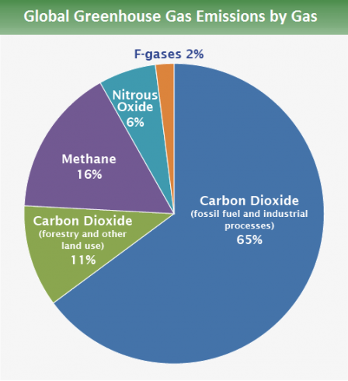
FIGURE 2: Global Greenhouse Gas Emission (EPA, 2018)

Electrolytic Conversion of Carbon Dioxide
The principle of electrolytic conversion of carbon dioxide is based on mutual oxidation and reduction, and carbon dioxide is converted into one of its reduced forms during this process. In true chemistry style, nothing is simplified, and thus reduction has multiple definitions. However, for the purpose of this article, I will use two definitions- “Reduction is the gain of oxygen” or “reduction is the gain of hydrogen”. Thus, during the process of electrochemical conversion, the carbon in CO₂ gains hydrogen or loses oxygen to form a variety of valuable products. For example, the carbon in CO₂ gains hydrogen to form methane or the carbon in carbon dioxide loses one oxygen to form carbon monoxide. In both the reactions, carbon dioxide experiences reduction. An interesting question crops up at this point. As mentioned in the above example, an electrolytic conversion of carbon dioxide may involve the formation of methane, an infamous greenhouse gas, therefore, this process may seem redundant. However, this conversion is of immense value because surplus carbon dioxide in the air is harnessed and converted into methane that can be used to generate heat and electricity (Waseda University, 2020). Hence, the methane formed via this conversion is not left free in the atmosphere for it to contribute towards global warming. Instead, it is employed as a renewable energy source. If you see, the conversion of carbon dioxide to methane serves two purposes- it reduces excess carbon dioxide concentration while generating a cleaner energy source, methane, as an alternative to the pollution releasing fossil fuels.
The electrolytic conversion of carbon dioxide is both practical and convenient. It is practical as it is controllable and has a significantly high conversion efficiency greater than 99% (Umeda et al., 2020).

Temperature/Pressure | The conversion can take place at room temperature and pressure. Drastic temperature and pressure conditions are not required.
Electrodes and catalysts | A wide variety of electrodes and catalysts are available to facilitate this reaction.
Easy and Economical | The method is easy to conduct and is cost-effective. Moreover, the electrolyte is often recovered at the end of the reaction, and the electrodes are recyclable. Thus, wastage is minimized.
Environment Friendly | Since chemical wastage is minimized, the method is environmentally friendly. Moreover, renewable sources of energy, such as geothermal energy, solar energy and hydro energy, are used to drive the reaction. Thus, electrical energy is used to bring about a chemical change.
Table 1: The main advantages of electrochemical conversion (AIP Conference Proceedings, 2019)

As stated above, various useful products can be made from CO₂, such as methane, formic acid, ethanol, graphene sheets and carbon monoxide, depending on the energy source/ reagent used. However, the main challenge is finding the right electrode and catalyst to facilitate the reaction. To be effective and efficient, a catalyst needs to have high activity, high product selectivity, and a low overpotential to drive the reaction. The Faradaic efficiency (the efficiency with which the charges/electrons transferred in a system enable an electrochemical change or the percentage of electrons contributing to the formation of a particular compound) is also an important point to consider. For instance, while Platinum electrodes can be used for converting CO₂ into CO, the further reduction into methane has proved to be a difficulty, due to the tendency of CO to get adsorbed on the surface of Platinum. A research paper by Minoru Umeda et al. (2020) suggests that platinum electrodes can be used to convert CO₂ into methane at low CO₂ partial pressures, and without overpotentials, that is, at potentials close to the thermodynamically determined equilibrium potential values. However, the Faradaic efficiency of the reaction remains at a low 6.8%. At present, the conversion of carbon dioxide into carbon monoxide, formic acid, ethylene and alcohols(methanol, ethanol, and propanol) occurs with high yield and holds incredible industrial values (Malkhandi et al. 2019). Carbon monoxide may be used for the manufacture of important chemicals such as acids and esters, formic acid is utilized in a variety of industries, including the poultry industry and tanning industry, ethylene is also a diverse chemical and is used in a range of industries, and alcohols find their use in perfumery, the paint industry, for manufacturing of printing inks, and in the pharmaceutical industry. Moreover, the reduction of carbon dioxide into carbon monoxide is highly facilitated due to the availability of highly selective catalysts with almost a 100% Faradaic efficiency. The catalysts used in the formation of carbon monoxide include Silver-based catalysts, Gold, Copper, Platinum and Cobalt-Phthalocyanine catalysts. At present, the cost of operating these electrodes and using these catalysts at a large-scale is very high. There is a need to actively develop breakthroughs for various reductions by finding appropriate electrodes and catalysts so that they can be used at the commercial level to convert vast amounts of CO₂ into different useful products to help save the world from the impending consequences of global warming.
Catalysts play a crucial role in facilitating the electrochemical conversion of CO_{2.} An electrocatalyst is primarily used to increase the efficiency of the reaction by accelerating the transfer of electrons between the electrode and the reactants, and/or to an intermediate chemical species formed by the overall half-reactions. Thus, an electrocatalyst seeks to reduce the activation energy of the overall reaction. Various electrocatalysts- metal-based catalyst, nanostructure catalysts, metal complex catalysts, transition metal catalysts, carbon nanotubes catalyst and carbon-metal nanocomposites have been used extensively in electrochemistry. Fig. 3 illustrates the use of these catalysts. For the electrochemical reduction of CO₂, a variety of metal catalysts, transition metal complex catalysts, and biocatalysts have been used.

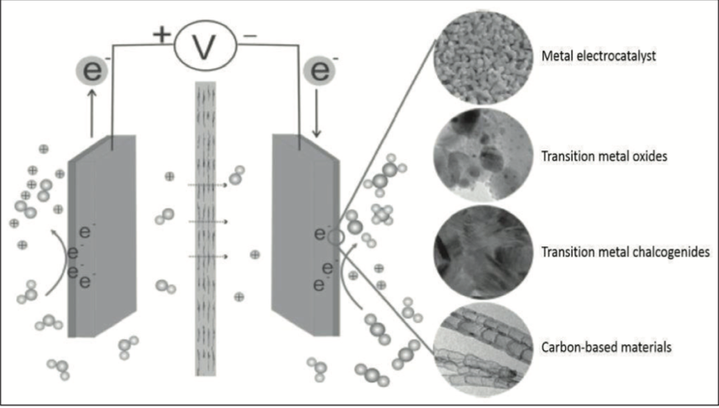FIGURE 3: Use of catalysts in Electrochemical Conversions (Reproduced from AIP Conference proceedings, 2019)

Catalysts need to possess two vital traits: high activity and stability. Catalysts selectivity is another critical factor that needs to be considered as it influences the cost of the reaction by reducing severe operating conditions. In this regard, nanostructured catalysts have gained considerable prominence in the field of green chemistry and in the electrochemical conversion of CO₂. Nanostructured catalysts have excellent activity, selectivity and stability. As is evident from the word, nanostructured refers to the structure of the catalyst. A substance that has a nanostructure has a structure between 1-100 nanometres. These catalysts are mostly metal-based. They are prepared with attention to crystalline pore size, pore structure, surface area, composition flexibility and component dispersion (Ying, 2006). All these properties make them an apt choice for electrochemical conversion of carbon dioxide. A paper by Dr Yang Song et al. shows the conversion of CO₂ to ethanol by using nanostructured copper as the catalyst. The Faradaic efficiency of the catalyst stands at a high 63%, while its selectivity is 84%. This enables the reaction to occur at ambient temperature and pressure conditions. The temperature-pressure condition is a critical condition, especially at the industrial level, as it determines the ease and the cost of the reaction. If the conversion can take place at room temperature and pressure conditions, it can easily be replicated numerous times, at low operational cost. Apart from metal-based catalysts, for some reductions, transitional element complexes, such as phthalocyanines, porphyrins, and bipyridines, have proved to be efficient catalysts. The main advantage of using metal-based complex catalysts is their ability to overcome high overpotential.
Electrochemical conversion of carbon dioxide is only one option. The recycling process can also be done using photochemical methods. The central difference between photochemical and electrochemical conversion is that in photochemical reaction light, or photons power the reaction, and in electrochemical conversion, electricity or electrons drive the reaction. However, both are based on the principle of oxidation-reduction.

Transcritical Carbon Dioxide
Conversion of carbon dioxide using electrochemical, photochemical or other similar methods is not the only way forward. The aim, to solve the problem of global warming, is to reduce the concentration of waste carbon dioxide in the air. This can be done by using carbon dioxide in its pure form as well. For instance, chemists have found that transcritical carbon dioxide is an excellent industrial refrigerant, and can be used in food processing facilities, supermarkets, warehouses and even ice-skating rinks. Transcritical carbon dioxide refers to the dynamic equilibrium state between the gas and liquid phase of carbon dioxide. When a building replaces usual refrigerants like chlorofluorocarbons and hydrofluorocarbons with transcritical carbon dioxide, two significant consequences are observed- the building’s climate impact decreases by 15% and its greenhouse gas emission also show downward trends (Esposito, 2016). Thus, if all the buildings in the world were to begin to use transcritical carbon dioxide as a refrigerant, the Earth would be a much cleaner and healthier planet.
In order to understand the working of carbon dioxide as an industrial refrigerant, it is essential to understand the phase diagram of carbon dioxide and the transcritical system and cycle.
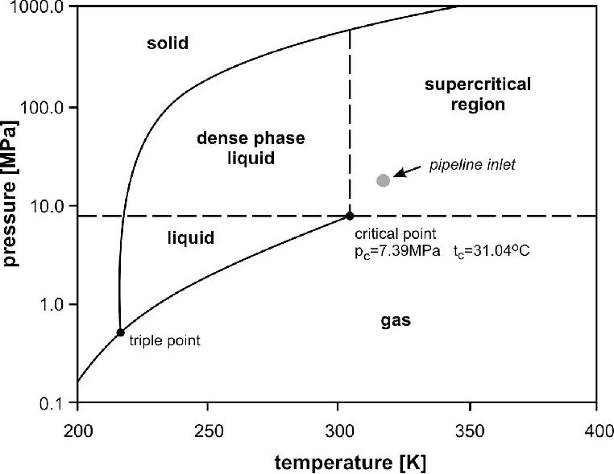
FIGURE 4: Phase Diagram of Carbon dioxide (Witkowski et al., 2014)

From Fig 4., it is evident that the critical point for carbon dioxide exists at a temperature of 31.04°C and pressure of 7.39MPa. Above this temperature, carbon dioxide cannot be liquified irrespective of the amount of pressure applied to it. The transcritical state is achieved beyond the critical point. Consequently, the main challenge of using transcritical carbon dioxide is the high pressure (greater than 7.39 MPa) involved in bringing CO2 to its transcritical state. At this state, even as carbon dioxide is cooled, it will not condense. Thus, this process of cooling carbon dioxide beyond its critical point is called gas cooling (Staub, 2004). The CO₂ condenser consists of a high-pressure gas cooler instead of an evaporator, and the cycle takes place between two isobars- one whose pressure value is lower than the critical pressure and the other whose pressure value is higher than the critical pressure. (Cavallini and Zilio, 2007). There is evidence that use of transcritical CO₂ is energy-efficient despite the high-pressure requirements during its manufacture because it is balanced by the amount of energy saved and the decrease in greenhouse emissions when it is used as a working fluid (Lecompte et al., 2019). The main advantage of using carbon dioxide as a refrigerant, apart from it being environmentally friendly, is that CO₂ is abundantly available, it is non-flammable, non-toxic, inert and compatible with all common materials encountered in the refrigerant circuit. It is interesting to note that though carbon dioxide is a greenhouse gas, using it as a refrigerant is considered harmless. The reason for this is that when CO₂ is used as a refrigerant, it is recovered from industrial waste. Therefore, the net greenhouse impact is considered to be zero (Cavallini and Zilio, 2007). For instance, carbon dioxide may be recovered from the iron and steel industry from the blast furnace gas, from the flue (waste) gas of the petrochemical industry and cement industry among others, and from ammonia production plants. Currently, there exist many technologies for the capture of carbon dioxide, including separation with solvents, separation using membranes, and via cryogenic distillation (Metz et al., 2005). The petrochemical and iron and steel industries used in the above example are nefarious for releasing vast amounts of carbon dioxide, thereby facilitating global warming. However, the technique of capturing carbon dioxide from their industrial emissions can go a long way in making these industries greener.

Carbon Dioxide to Biomass by Using Algae
Recycling and reusing carbon dioxide, as stated before, are based on the principle of CCU. Another prevalent technique to limit the concentration of carbon dioxide in the air is CCS- Carbon dioxide Capture and Storage. The CCS technology has the potential to capture up to 90% of the carbon dioxide released during industrial processes, thus preventing the increase in the concentration of the gas in the atmosphere (American Associates, 2020). According to certain scientists, CCS methods may be more favourable than CCU techniques in reducing the extent of global warming (Cuellar-Franca & Azapagic, 2015). Mainstream CCS technologies involve carbon dioxide storage in geological formations. While these methods have also shown promise in reducing carbon dioxide greenhouse emissions, they may have negative side effects such as an increase in acidification of the oceans (Cuellar-Franca & Azapagic, 2015). While preliminary research indicates that the long-term benefits of such CCS techniques may be vast, deeper research needs to be conducted, and regulations need to be introduced to overcome any possible side-effect for maximum future gain (Shahbazi & Nasab, 2016). However, there is another aspect to consider. Under the umbrella of CCS is a particularly interesting and valuable concept of Bio-CCS. This refers to the role of biomass in propagating CCS. The technique of using biomass to store CO₂ is immensely advantageous as it has the capacity to ensure the net removal of surplus carbon dioxide, provided that the use and production of biomass are done employing green methods (University of Saskatchewan, 2017). Interestingly, humans can use algae to produce biomass. A well-known fact is that carbon dioxide is used by plants during photosynthesis. This natural cycle helps regulate the amount of carbon dioxide in the air. However, as stated before, with urbanization and industrialization, natural processes are no longer sufficient to balance the amount of carbon dioxide in the air. By replicating the process of photosynthesis, researchers have devised an interesting method to recycle carbon dioxide. Algae, when used in combination with bioreactors, is up to 400 times more efficient than a tree at eliminating excess carbon dioxide. If this process is used correctly, it has the potential to turn a city’s carbon footprint into negative values without changing any consumption patterns (Lamm, 2019). Algae consume more carbon dioxide than trees primarily because it has a larger surface area; it grows faster than trees and can be more easily controlled by bioreactors. By recycling carbon dioxide as food for algae, a variety of environmental problems can be mitigated. The process of growing algae is facilitated by photobioreactors. When carbon dioxide is consumed, it is used by the algae in making skeleton for lipids, proteins, sugars and pigments (Sydney et al. 2010). Photobioreactors use light sources to cultivate phototrophic microorganisms like algae, and algae, in turn, consume carbon dioxide and light to manufacture biomass. The biomass produced by this process is a valuable source of energy and has the immense potential to contribute towards the global fuel requirements in the future (Ullah et al., 2014). Moreover, these biofuels are sulphur-free, completely non-hazardous, are 100% biodegradable (Marsh, 2009).
Algae have a high potential as a source of biomass as they possess high photosynthetic efficiencies (energy stored per mole of oxygen consumed). Biomass, a renewable energy source, can be converted into a plethora of valuable products and fuels such as biofuels, biogas, and biodiesel that can be substituted for fossil fuels and find application in almost every industry. Algae-based production systems of biomass seem promising as a long-term economically viable alternative to fossil fuels and as a potential source of carbon capture. Apart from industrial uses, the microalgae cultivated in photobioreactors can also be used to revive oyster reefs (University of Maine, 2017). The Dornoch Environmental Enhancement Project (DEEP) aims at restoring an oyster reef that existed about a hundred years ago at the Dornoch Firth, an area of thriving biodiversity. This project has shown immense success as the oyster reefs have shown signs of revival. Carbon dioxide played an integral role here. The CO₂ produced during the whisky fermentation process at Glenmorangie Distillery at Dornoch was used to grow the algae. These algae were then fed to oysters that were being nurtured for the revival of the reef. It was found that 80% of these oysters survived in the waters of Dornoch Firth. (Pultarova, 2019 & The Glenmorangie Company, 2018). This method is ground-breaking and may even be employed in other seas for the restoration of bygone reefs. Thus, by the transitive property, recycling carbon dioxide can be indirectly useful for reviving oyster reefs.

Dry Reforming of Methane
Reusing greenhouses is not limited only to carbon dioxide. In Fig 1., it can be seen that the second most abundant greenhouse gas after carbon dioxide is methane. According to professors and researchers at the University of Saskatchewan, carbon dioxide and methane from industrial waste can be reused together in a reaction called “dry reforming of methane” to produce syngas. Syngas, a mixture of carbon monoxide and hydrogen is used to synthesis several types of fuels and ammonia. This reaction has still not been scaled up for commercial use mainly due to the lack of an industrially viable catalyst. (University of Saskatchewan, 2017). It has been found that metals such as Nickle based catalysts are the best for commercialization of dry reforming of methane. However, further research needs to be conducted in this area before it can be extensively commercialized.

Conclusion
It is important to note that in both CCU and CCS techniques, carbon dioxide is not being eliminated- it is only being reused or recycled. The CCU and CCS techniques are all carbon-neutral energy cycles. The implication of carbon-neutral cycle is that the net carbon footprint or greenhouse gas emission is nil- carbon dioxide that is generated as a waste product from one process is reused or recycled for another process, and this cycle continues. Thus, by employing these techniques, the rate of increase in carbon dioxide will remain more or less constant since the same CO₂ will get reused over and over again. The principle of CCU can be beneficial only if the subsequent reduction in greenhouse emissions offsets the energy required for the reuse of carbon dioxide. The use of renewable energy (such as solar and wind energy) as a vehicle for recycling and reusing carbon dioxide, though expensive, is one of way to ensure this. The problem of high energy, along with the high cost of employing these strategies, are a massive challenge in the way of commercializing CCU and CCS techniques. At present, Bio-CCS techniques show more promise than conventional CCS techniques in terms of overall environmental benefit. Therefore, while the technique of CO₂ reuse and recycling shows immense promise for a sustainable future, much research needs to be conducted in this area before launching it at a global level to ensure maximum benefits (Olfe-Krautlein, 2020).
Since the advent of time, humans have continually aimed at making a better and more efficient world. Ironically, in our endeavour to create a “better” and more advanced world, we have destroyed our home planet. There have been severe consequences of industrialization and urbanization, one of them being global warming. In the past few years, global warming has been increasing at an exponential pace, and there is a pressing need to act and listen to the voice of the Earth. Recycling and reusing of carbon dioxide, via CCU and CCS methods, have emerged as viable alternatives for decreasing the concentration of waste CO₂ in the atmosphere, thereby reducing the extent of greenhouse emissions. Based on the model of carbon dioxide recycling, scientists must explore similar techniques for other greenhouse gases as well, the dry reforming of methane being one example. If achieved successfully, these practices could reduce global warming by a large extent. Years of exploitation of the planet cannot be undone easily or quickly. Identifying methods such as the electrolytic conversion of carbon dioxide to beneficial products, the usage of carbon dioxide as a refrigerant, and conversion of CO₂ into biomass and its implications are ground-breaking as they indicate a path to undo the damages of global warming. A breakthrough in science to make these processes commercially practicable could lead to massive cuts in the concentration of waste CO₂ in the atmosphere- a step in the right direction. With sustainable development being the key focus area for Earth’s future, there is a need to actively pursue research in this area and to overcome the hurdles to make CCU and CCS methods successful in mitigating the impact and rate of global warming.

References:
American Associates, Ben-Gurion University of the Negev. (2020, March 10). Biomass fuels can significantly mitigate global warming. ScienceDaily. https://www.sciencedaily.com/releases/2020/03/200310094244.htm
Cavallini, A., & Zilio, C. (2007). Carbon dioxide as a natural refrigerant. International Journal of Low-Carbon Technologies, 2(3), 225–249. https://doi.org/10.1093/ijlct/2.3.225
Centre for Sustainable Systems, University of Michigan. (2020, October). Climate Change: Science and Impacts Facts Sheet. http://css.umich.edu/sites/default/files/Climate%20Science_CSS05-19_e2020.pdf
Climate change and health. (2018, February 1). https://www.who.int/news-room/fact-sheets/detail/climate-change-and-health
Cuéllar-Franca, R. M., & Azapagic, A. (2015). Carbon capture, storage and utilisation technologies: A critical analysis and comparison of their life cycle environmental impacts. Journal of CO2 Utilization, 9, 82–102. https://doi.org/10.1016/j.jcou.2014.12.001
Environmental Protection Agency. (2020, September 9). Sources of Greenhouse Gas Emissions. EPA. https://www.epa.gov/ghgemissions/sources-greenhouse-gas-emissions
Esposito, M. (2016, October 17). 4 ways green chemistry is helping make the world a better place. World Economic Forum. https://www.weforum.org/agenda/2016/10/4-ways-green-chemistry-is-helping-make-the-world-a-better-place/
The Glenmorangie Company. (2018). The Glenmorangie Deep initiative - About the project. Youtube. https://www.youtube.com/watch?v=75ZEDLWJV40
Githeko, A. K., Lindsay, S. W., Confalonieri, U. E., & Patz, J. A.
(2000). Climate change and vector-borne diseases: a regional analysis. Bulletin of the World Health Organization, 78(9), 1136–1147.
Hussein, F., & Aroua, M. K. (2019). Recent development in the electrochemical conversion of carbon dioxide: Short review. AIP Conference Proceeding . https://doi.org/10.1063/1.5117139
The IUCN Red List of Threatened Species. IUCN Red List of Threatened Species. https://www.iucnredlist.org/
Lamm, B. (2019, October 1). Algae might be a secret weapon to combatting climate change. Quartz. https://qz.com/1718988/algae-might-be-a-secret-weapon-to-combatting-climate-change/
Lecompte, S., Ntavou, E., Tchanche, B., Kosmadakis, G., Pillai, A., Manolakos, D., & Paepe, M. D. (2019). Review of Experimental Research on Supercritical and Transcritical Thermodynamic Cycles Designed for Heat Recovery Application. Applied Sciences, 9(12), 2571. https://doi.org/10.3390/app9122571
Loria, K. (2018, May 9). CO2 levels are at their highest in 800,000 years. https://www.weforum.org/agenda/2018/05/earth-just-hit-a-terrifying-milestone-for-the-first-time-in-more-than-800-000-years
Malkhandi, S., & Yeo, B. S. (2019). Electrochemical conversion of carbon dioxide to high value chemicals using gas-diffusion electrodes. Current Opinion in Chemical Engineering, 26, 112–121. https://doi.org/10.1016/j.coche.2019.09.008
Marsh, G. (2009, February 1). Biomass from algae. Biomass from algae - Renewable Energy Focus. http://www.renewableenergyfocus.com/view/931/biomass-from-algae/
Methane and the Environment: SoCalGas. SoCalGas, A Sempra Energy utility. https://www.socalgas.com/stay-safe/methane-emissions/methane-and-the-environment
Metz, B., Davidson, O., de Coninck, H., Loos , M., & Meyer, L. (Eds.). (2005). Ipcc Special Report on Carbon Dioxide Capture and Storage. Cambridge University Press.
Olfe-Kräutlein, B. (2020). Advancing CCU Technologies Pursuant to the SDGs: A Challenge for Policy Making. Frontiers in Energy Research, 8. https://doi.org/10.3389/fenrg.2020.00198
Pultarova, T. (2019, February 19). Six ideas for CO2 reuse: a pollutant or a resource? Engineering and Technology. https://eandt.theiet.org/content/articles/2019/02/six-ideas-for-co2-reuse-a-pollutant-or-a-resource/
Ritchie, H., & Roser, M. (2017, May 11). CO₂ and Greenhouse Gas Emissions. Our World in Data. https://ourworldindata.org/co2-and-other-greenhouse-gas-emissions
Shahbazi, A., & Nasab, B. R. (2016). Carbon Capture and Storage (CCS) and its Impacts on Climate Change and Global Warming. Journal of Petroleum & Environmental Biotechnology, 7. https://doi.org/10.4172/2157-7463.1000291
Song, J. T., Song, H., Kim, B., & Oh, J. (2019). Towards Higher Rate Electrochemical CO2 Conversion: From Liquid-Phase to Gas-Phase Systems. Catalysts, 9(3). https://doi.org/10.3390/catal9030224
Song, Y., Peng, R., Hensley, D. K., Bonnesen, P. V., Liang, L., Wu, Z., … Rondinone, A. J. (2016). High-Selectivity Electrochemical Conversion of CO2to Ethanol using a Copper Nanoparticle/N-Doped Graphene Electrode. ChemistrySelect, 1(19), 6055–6061. https://doi.org/10.1002/slct.201601169
Staub, J. (2004, January 26). CO2 As Refrigerant: The Transcritical Cycle. ACHR News RSS. https://www.achrnews.com/articles/94092-co2-as-refrigerant-the-transcritical-cycle
Storing and Recycling CO2: Lots of Ways to Do It with Biomass. Environmental and Energy Study Institute. (2011, December 9). https://www.eesi.org/articles/view/storing-and-recycling-co2-lots-of-ways-to-do-it-with-biomass
Sydney, E. B., Sturm, W., Carvalho, J. C. D., Thomaz-Soccol, V., Larroche, C., Pandey, A., & Soccol, C. R. (2010). Potential carbon dioxide fixation by industrially important microalgae. Bioresource Technology, 101(15), 5892–5896. https://doi.org/10.1016/j.biortech.2010.02.088
Technology Networks. (2018, November 26). Green Chemistry "Recycles" Carbon Dioxide. Applied Sciences from Technology Networks. https://www.technologynetworks.com/applied-sciences/news/green-chemistry-recycles-carbon-dioxide-312200
Thompson, A. (2017, November 14). Reducing Fossil Fuel Emissions Isn't Stopping CO2 Rise. Popular Mechanics. https://www.popularmechanics.com/science/environment/news/a27096/reducing-fossil-fuel-emissions-isnt-stopping-co2-rise/
Ullah, K., Ahmad, M., Sofia, Sharma, V. K., Lu, P., Harvey, A., … Anyanwu, C. N. (2014). Algal biomass as a global source of transport fuels: Overview and development perspectives. Progress in Natural Science: Materials International, 24(4), 329–339. https://doi.org/10.1016/j.pnsc.2014.06.008
Umeda, M., Niitsuma, Y., Horikawa, T., Matsuda, S., & Osawa, M. (2020). Methane on Platinum Catalysts without Overpotentials: Strategies for Improving Conversion Efficiency. ACS Applied Energy Materials, 3, 1119–1127. https://doi.org/10.1021/acsaem.9b02178
University of Maine. (2017, July 21). Growing Algae to Feed Oysters - College of Engineering - University of Maine. College of Engineering. https://engineering.umaine.edu/2017/07/20/algae-growth-feed-oysters/
University of Saskatchewan. (2017, August 30). Researchers develop technique to reuse carbon dioxide and methane. Phys.org. https://phys.org/news/2017-08-technique-reuse-carbon-dioxide-methane.html
Waseda University. (2020, February 27). New method converts carbon dioxide to methane at low temperatures. ScienceDaily. https://www.sciencedaily.com/releases/2020/02/200227114523.htm.
Watts, J. (2020, May 8). Sea levels could rise more than a metre by 2100, experts say. https://www.theguardian.com/environment/2020/may/08/sea-levels-could-rise-more-than-a-metre-by-2100-experts-say
Witkowski, A., Majkut, M., & Rulik, S. (2014). Analysis of pipeline transportation systems for carbon dioxide sequestration. Archives of Thermodynamics, 35(1), 117–140. https://doi.org/10.2478/aoter-2014-0008
Ying, J. Y. (2006). Design and synthesis of nanostructured catalysts. Chemical Engineering Science, 61(5), 1540–1548. https://doi.org/10.1016/j.ces.2005.08.021

